PORTAFLOW 300
Ultrasonic Flowmeter Manual


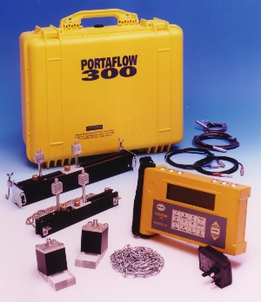

Micronics Ltd, Knaves Beech Business Centre, Davies Way, Loudwater, High Wycombe, Bucks HP10 9QR.
Tel: 01628 810456 Fax: 01628 531540
e-mail: sales@micronicsltd.co.uk www.micronicsltd.co.uk

CONTENTS
 |  | PAGE No. |  |  |  |  |  |  |  |  | PAGE  No.
Introduction |  | 3 |  |  |  |  |  | Messages |  |  | 22
Fast Track Set up Procedure |  | 3 |  |  |  |  |  | Status |  |  | 22
 |  |  |  |  |  |  |  | Error |  |  | 22
 |  |  |  |  |  |  |  | Warning |  |  | 22/23
Connectors |  | 4
Parts and Accessories |  | 4
Charger |  | 5 |  |  |  |  |  | Application Information |  |  | 24
Battery |  | 5 |  |  |  |  |  | Transducer Positioning |  |  | 24
Keypad |  | 5 |  |  |  |  |  | Mounting the Transducers |  |  | 25
Temperature Indication/Range |  | 5 |  |  |  |  |  | Liquid Conditions |  |  | 26
Transducers |  | 5 |  |  |  |  |  | Reynolds Number |  |  | 26
Separation Distance |  | 6 |  |  |  |  |  | Propagation Velocity |  |  | 26
Attaching the Transducers |  | 6 |  |  |  |  |  | Maximum Flow |  |  | 27
Ultrasonic Couplant |  | 7 |  |  |  |  |  | Application Temperature |  |  | 27
Fluid Types |  | 7 |  |  |  |  |  | Flow Range |  |  | 27
 |  |  |  |  |  |  | Liquid Sound Speeds |  |  | 28
Programming/Main Menu | 8 |  |  |  |  |  | Solid Sound Speeds |  |  | 32
Quick Start | 8
View/Edit Site Data |  | 10 |  |  |  |  |  | Specification |  |  | 33
Select Sensor Set |  | 11 |  |  |  |  |  | CE Marking Guidance Notes |  |  | 34
Data Logger |  | 11 |  |  |  |  |  | Warranty |  |  | 34
Download to Windows 95 |  | 14 |  |  |  |  |  | Battery charge procedure |  |  | 35/36
Download to Windows 3.1 |  | 15
Set up RS232 |  | 16
Set up Portaflow |  | 17
Read Flow |  | 18
Keypad Options |  |  | 18
Logger Key |  |  | 18
4 - 20 mA Output Key |  |  | 19
RS232 Output Key |  |  | 20
Delete Key |  |  | 20
Pulse Output Key |  |  | 20
Options Key |  |  | 21

WARNING - Users should ensure or note that:

a) The PORTAFLOW 300 is not certified for use in Hazardous areas.
b) The local site safety regulations are complied with.
c) Work is carried out in accordance with The Health & Safety at Work Act 1974.
d) Please follow the note on page 35-36 of this manual detailing the Charging and discharging of the internal batteries.

INTRODUCTION
The PORTAFLOW™ 300 is a portable flowmeter designed by Micronics for use on liquid flows in full pipes, which utilises “Clamp-On” Transducers.

Easy to operate, the Portaflow 300 features are:
- Large easy to read Graphics Display with backlighting.
- Simple FAST TRACK set up procedure.
- Simple to follow keypad
- IP66 electronics enclosure
- IP66 rated sockets
- Guide rail assemblies that include optional magnets (for steel pipes above 89mm (3½”) diameter).
- 112k memory logger
- RS232 output
- Pulse output
- 4-20mA or 0-20mA output
- 24hr Battery (rechargeable)
- Self checking diagnostics
- Battery management
- Continuous signal monitoring

The instrument displays volumetric flow rate in M³/hr, M³/min, M³/sec, g/min, USg/hr, l/min, l/sec and linear velocity in metres and feet per second. When in flow mode the total volumes both positive and negative are displayed, up to a maximum 12digit number.

The Standard Portaflow 300 is supplied in a carrying case, laid out as shown in Figure 1. Transducer sets ‘A’ and ‘B’ are standard. Transducer set ‘C’ is an optional extra. A further transducer set ‘D’ is also available but is supplied in a separate carrying case.

The following simple guide will enable the user to quickly set up the meter to measure flow. Additional data on the facilities available and many useful hints are contained in the latter sections of this manual.
Figure 1

Fast Track Set up Procedure
- Switch on and press ENTER.
- Check battery level - If the battery symbol on the display is full, the unit is charged, press ENTER.
- Select Quick Start - Press ENTER.
- Dimension Units – Select units required. Press ENTER.
- Outside Diameter – Enter data, press ENTER.
- Pipe Thickness – Enter data, press ENTER.
- Pipes Lining Thickness – Enter data, press ENTER.
- Pipe Wall Material – Select using scroll keys, press ENTER.
- Pipe Lining Material – This will only be displayed if a thickness has been entered. Select using scroll keys. Press ENTER.
- Fluid Type – Select using scroll keys. Press ENTER.
- The instrument selects the default transducers using the data entered and now displays the following.
ATTACH SENSORS yy-mm-dd hh:mm:ss

Attach sensor set X in XXXXXX mode
(RED connector UPSTREAM)
Approx. max. flow: X.XX m/s

Press ENTER to continue
or SCROLL to select another sensor

The sensor set can be ‘A’, ‘B’, ‘C’ or ‘D’ and the mode Reflex or Diagonal. Use the guide rail selected by the instrument and retract the sensor blocks back into the guide rail by turning the knurled knobs clockwise. If transducer ‘C’ is selected and these blocks are available, remove ‘B’ transducer set from the guide rail and replace with ‘C’ transducer set.

- Apply couplant to both sensor blocks as shown, then attach to the pipe using the appropriate mounting hardware.
Figure 2
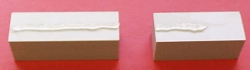

In most cases the guide rail selected will suit the application. The user can choose another rail and/or sensors to increase sensitivity, signal strength or to change the flow range (See page 9- Select Sensor Set).
Pin 3
RS232 RXD white

Pin 2
RS232 TXD

Pin 6
RS232 DSR red
Pin 4
RS232 DTR Black

Pin 5
GND screen
Pin 1(marked)
RS232 DSR red

Pin 2
RS232 DTR black

Pin 3
GND screen

Pin 5
RS232 RXD white

Pin 4
RS232 TXD green

Figure 3 - Example: - Reflex Mode Operation
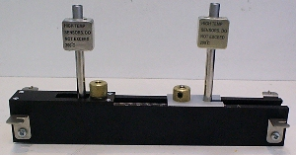
Separation
Distance

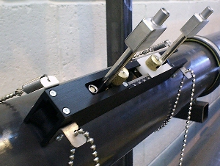

Note: If the instrument has selected ‘B’, ‘C’ or ‘D’ transducer set to work in DIAGONAL MODE, the floating transducer has to be removed and placed on the opposite side of the pipe. Use the diagonal beam guide rail and the appropriate mounting hardware to attach the floating transducer (See page 5 - Attaching the Transducers).

- Connect the red/blue and black sensor cables to both the electronics and the guide rail assembly. The red cable indicates +ve flow if upstream.

Note: - To remove the cable connectors from the sensor blocks, fully retract each block into the guide rail by turning the knurled knob clockwise. DO NOT pull on the cables.

- Attach to the pipe as shown on page 5. Turning the knurled knob anti-clockwise, screw the fixed transducer to the pipe making finger tight contact.

- Press ENTER and the display will show the separation distance in mm.

- Set the separation distance (See figure 3 above) by sliding the floating transducer along the scale until the front edge of the block is at the recommended distance. Now turn the knurled knob anti-clockwise, until in finger tight contact with the pipe surface.

- Press ENTER to read flow.

Pressing the appropriate key can change flow units. An additional key press will change the timescale of the reading - hr/min/sec.
Figure 4
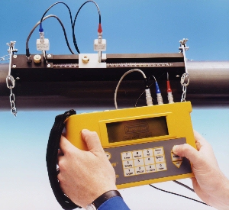

HARDWARE

Connectors
There are six connectors on the electronic housing, three of which directly connect to the transducer assemblies and three are for the output facilities.
Figure 5
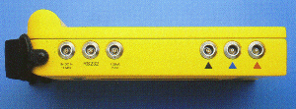

4 - 20mA and Pulse Cable Connections
4 - 20mA - Red (positive), Black (negative).
Pulse - White (positive), Green (negative).

RS232 Cable Connections

Figure 6
9 way ‘D’ plug viewed from reverse
Pin 4 RS232 DTR black

Pin 3 RS232 RXD white

Pin 5 GND screen

Pin 2 RS232 TXD green

Pin 6 RS232 DSR red

5 pin plug viewed from reverse
Pin 1 (marked) RS232 DSR red
Pin 3 GND screen
Pin 4 RS232 TXD green
Pin 5 RS232 RXD white
Pin 2 RS232 DTR black

Parts and Accessories
The Portaflow 300 is supplied in a rugged IP68 carrying case. The equipment is housed in a foam insert inside the case to give added protection for transportation.

Standard Parts
- Electronic instrument with backlit graphic display.
- Logger included as standard.
- Power supply - with UK, US, European adapters. 110/240VAC.
- Ultrasonic couplant.
- Manual.
- 4 lengths of chain each at 3.3 metres long
- Sensor cables 2 metres long.
- 4-20mA, Pulse Output and RS232-C cables.

Options

Guide Rail Assembly ‘A’ - Includes sensors for pipe ID 13mm to 89mm. Temperature range -20°C to +200°C.

Guide Rail Assembly ‘B’ - Includes sensors for pipe ID 90mm to 1000mm. Temperature range -20°C to +200°C.

Guide Rail for use in Diagonal Mode

Magnetic assembly - Diagonal and ‘B’ guide rail Assembly.

Transducer set ‘C’ - High Velocity Transducers for pipes 300mm to 2000mm, in guide rail ‘B’.

Transducer kit ‘D’ - Sensors include ratchet straps for pipes 1000mm to 5000mm. Temp range -20°C to +80°C.

Extra chain is available on request.

Calibration certificate with (NAMAS accreditation)

Charger (Use only the charger supplied.)
The battery takes 15 hours to fully charge. When the instrument is charging, but switched off, the display reads ‘CHARGING’. It also displays a battery and plug symbol. CHARGING is displayed under the word ‘Battery’ when on charge in flow mode, and a ‘plug’ symbol is displayed in place of the battery symbol.

Battery
When you first receive your unit put the battery on charge for a minimum of 15hrs. When fully charged the battery will last up to 24hrs, depending on the outputs used and how often the backlight is operated. If the backlight has been enabled, every time a key is pressed it comes on for 15 seconds. If the backlight is active continuously the battery life would reduce to 8hrs. If the 4-20mA is used constantly at 20mA, the battery life would reduce by 20%.

The display in flow mode continually shows the battery level as a percentage. When this indication reads approximately 40%, it will display a warning message. This indicates there is only 30 minutes of use left in the battery. The battery can be charged while the instrument is in use or while the instrument is switched off. The battery can also be partially charged and then used.

Keypad
Programming is via the tactile membrane keypad with rim embossed keys. The keypad is rated at IP67.

Figure 7
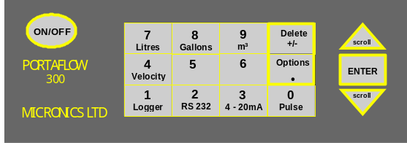
By selecting keys 4, 7, 8 and 9 it is possible to change the velocity and volumetric flow reading. Press the key more than once to change the display.

- Press 4 > m/s, press 4 > f/s
- Press 7 > l/s, press 7 > l/min
- Press 8 > g/min, press 8 > USG/min
- Press 9 > m³/hr, press 9 > m³/min, press 9 > m³/sec

There are also some facilities that require you to move the cursor on the display left and right as well as up and down. This is done with keys 5 (left) and 6 (right).

The 4-20mA, Pulse, RS232 and logger keys can only be activated from flow mode (See page 19 - Keypad Options). The RS232 and data logger is also on the MAIN MENU.

Temperature Indication/Range
The transducers work over two temperature ranges. The standard temperature range is from -20°C to +200°C. The high temperature range is from -20°C to +200°C. When in flow mode the application temperature is only displayed if the prop/temp sensor cable is connected. Inside the transducer block is the PT100 sensor, which produces the temperature reading. This reading will change if the temperature of the application changes. The instrument can only compensate for a temperature change of ±10°C when reading flow.

Transducers
The Portaflow 300 uses four different transducer sets. They are called ‘A’, ‘B’, ‘C’ and ‘D’. The instrument selects transducer sets, depending on the data entered (i.e. the pipe size and flow velocity). There are default pipe ranges programmed into the instrument and most of the time there will be no need to change these. However it is possible to use different transducer sets on different pipe sizes outside their normal operating range (See page 9 - Select Sensor Set). The Portaflow 300 will only let you use the sensors supplied with the instrument. If other sensors were required software information would be supplied when purchased, for the user to program.

Transducer sets are positioned in the guide rail, to help correctly align the transducer blocks along the pipe axis. Both the ‘A’ and ‘B’ guide rails have two transducer blocks. One is fixed and the other is moveable and slides along the scale to enable the user to set the separation distance (See figure 4, page 2). The instrument calculates the separation distance when the application information has been entered. The fixed sensor can be identified because it is slightly longer and has two connections as opposed to the floating block only having one connection.

Each guide rail should be mounted on the surface of the pipe using the hardware provided. Magnetic attachments are available as an option with the ‘B’ guide rail.

Transducer set ‘A’
Supplied as standard for use on pipes 13mm to 89mm inside diameter. After applying the grease, attach to the pipe using the ball chain and spring attachment. Magnets are not available for this guide rail.

Transducer sets ‘B’ and ‘C’
The ‘B’ guide rail is attached to the pipe using the chains provided. Two types of transducer block fit into the ‘B’ guide rail. The ‘B’ transducers are used on pipes from 90mm to 1000mm. The ‘C’ transducers measure double the velocity range of the ‘B’ transducers on pipes from 300mm to 2000mm inside diameter. Magnetic attachments are available to fit onto this guide rail.

Transducer Kit ‘D’
The ‘D’ transducers are for use on pipes from 1000mm to 5000mm, and supplied with their own guide rail and mounting hardware. They are aligned in the same way as other transducer sets (i.e. Reflex or Diagonal mode) with the separation distance being measured from the front edge of the block. The transducers are made from perspex with a maximum operating range up to +80°C. It is not necessary or possible to attach the Prop/Temp cable to the ‘D’ sensors.

Separation Distance
The instrument calculates the separation distance when all the parameters have been entered. The fixed transducer must be in contact with the pipe surface when a propagation measurement needs to be made. The next stage is for the second or moveable transducer to be placed on the pipe, at the required separation distance. Screw down onto the pipe surface making sure not to over tighten, as it may force the fixed sensor off the pipe wall - finger tight is sufficient!

The separation distance is the distance between the front edge of each sensor block. See Figure 3, page 2, for an example in reflex mode. Connections are made via the IP66 connectors between the sensor block and the electronics.

Attaching The Transducers
Attach the guide rail to the pipe using the hardware provided.

Figure 8 – Reflex Mounting Hardware – Transducer set ‘A’
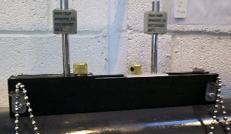

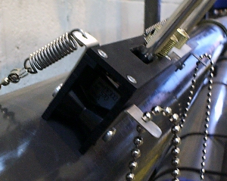

Figure 9 - Reflex Mounting Assembly - Transducer sets ‘B’ and ‘C’
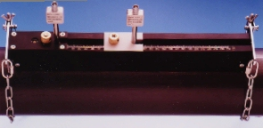

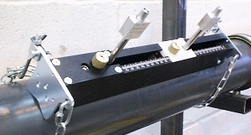

Figure 10 - Diagonal Beam Mounting Hardware for Transducer Sets ‘B’ & ‘C’.
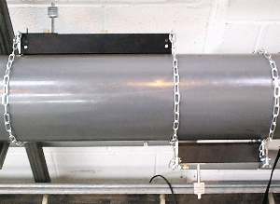

Figure 11 – Reflex Mounting for Transducer Set ‘D’
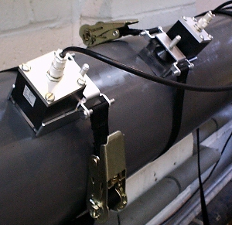

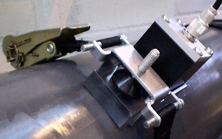

Ultrasonic Couplant
Ultrasonic couplant must be used on the transducer face to interface with the pipe wall. (See pages 1).

Fluid Types
Portaflow 300 is capable of measuring clean liquids or oils that have less than 3% by volume of particulate content. Cloudy liquids like river water and effluent can be measured along with cleaner liquids, like demineralised water.

During the set up procedure the user is asked to select from a list of liquids that include water and oils. If the liquid to be measured is not listed it is possible for the instrument to measure the propagation rate (See fluid type page 5 and Fluid prop rate page 21).

Applications include: - River water, Seawater, Potable water, Demineralised water, Treated effluent, Water/Glycol systems, Hydraulic systems and Diesel oil.
PROGRAMING/MAIN MENU


Switch 0n…
Micronics Ltd.

Serial 0000 v 2.00
Press Enter to start

Main Menu
Press SCROLL up or down to move cursor to required option and press ENTER to select. Before accessing the flow and data logging facilities, please ensure that date and time details are correct (see page 15, Main Menu-Set-up Portaflow)
MAIN MENU yy-mm-dd hh:mm:ss
Quick start
View/Edit Site Data
Select sensor set
Data Logger
Set up RS232
Set up Portaflow
Read flow

Main Menu - Quick Start
Selecting quick start offers the user the easiest and quickest option to achieve flow measurement. If the instrument has already been used, it stores the last application data entered. This allows the user to read flow on the same application without spending time entering new data. Go to ‘Read Flow’ in the main menu.

If QUICK START is selected, proceed with the following routine. Use the scroll keys to select,
then press ENTER.
QUICK START yy-mm-dd hh:mm:ss

Select the dimension units:

Millimetres
Inches

The instrument now asks for the Pipe outside diameter? After entering the outside diameter press ENTER.

QUICK START yy-mm-dd hh:mm:ss

Dimension units MILLIMETRES

Pipe outside diameter? 58.0
Pipe wall thickness now appears on the display. After entering the pipe wall thickness, press ENTER.
QUICK START yy-mm-dd hh:mm:ss

Dimension units MILLIMETRES

Pipe outside diameter? 58.0
Pipe wall thickness? 4.0

Pipe lining thickness now appears on the display. If the pipe you are measuring has a lining, enter the Pipe lining thickness. If nothing is entered the instrument automatically assumes there is no lining. Press ENTER to move on. If the application has a lining, enter the required thickness in the units selected. Press ENTER to continue.
QUICK START yy-mm-dd hh:mm:ss

Dimension units MILLIMETRES

Pipe outside diameter? 58.0
Pipe wall thickness? 4.0
Pipe lining thickness? 0.0

The instrument now displays Select pipe wall material. By using the scroll keys it is possible to scroll up or down the options available.
QUICK START yy-mm-dd hh:mm:ss

Select pipe wall material:

Mild Steel
S’ less Steel 316
S’ less Steel 303
Plastic
Cast Iron
Ductile Iron
Copper
Brass
Concrete
Glass
Other (m/s)

Select the required material and press ENTER.
The following will only be displayed at this stage if a lining thickness has been entered. Use the scroll keys to select the required material then press ENTER. If Other is selected, enter the propagation rate of the lining in metres/sec. Contact Micronics if this is not known.

QUICK START yy-mm-dd hh:mm:ss

Select pipe lining material:

Steel
Rubber
Glass
Epoxy
Concrete
Other (m/s)

Select fluid type now appears on the display.
Use the scroll keys to select the fluid type and press ENTER. If Measure is selected, the instrument automatically measures the propagation rate of the liquid. If the liquid is not listed select Other and enter a propagation rate in metres/second. This may be found in the back of the manual under Liquid Sound Speeds.
QUICK START yy-mm-dd hh:mm:ss

Select fluid type:
Water
Glycol/water 50/50
Lubricating oil
Diesel oil
Freon
Measure
Other (m/sec)

Attach Sensors
The instrument will now provide the user with details of the sensor type to be attached to the pipe and the mode of operation. It will also give the approximate maximum flow that can be achieved with the sensors that have been selected.

It is possible to view other flow units to display the maximum volumetric flow. Use the keypad to select a flow unit.

Connect the RED, BLUE and BLACK sensor cables, between the guide rail and the electronics.
ATTACH SENSORS yy-mm-dd hh:mm:ss

Attach sensor set A in REFLEX mode
(RED connector upstream)
Approx. max. flow: 7.20 m/s

press ENTER to continue
or SCROLL to select another sensor

It is not essential to connect the black cable. If the instrument cannot find a temperature signal, it asks the user to try again. Pressing ENTER will make the instrument try again or scroll will prompt the user to enter a value. When a value is entered press ENTER.
ATTACH SENSORS yy-mm-dd hh:mm:ss

No signal from temp sensor

Press ENTER to try again or
SCROLL to enter a value

If the black cable is connected pressing ENTER will give a separation distance. If it is not connected the temperature should be entered.
ATTACH SENSORS yy-mm-dd hh:mm:ss

FLUID TEMPERATURE (°C) 20.0
Set sensor separation to 34

Press ENTER to continue

Note:-
- The fluid temperature will only be displayed in flow mode when entered manually.
- The separation distance is displayed in mm.

READ FLOW now appears on the display.
READ FLOW yy-mm-dd hh:mm:ss
(ERROR MESSAGES APPEAR HERE)
Battery
100%
Signal
83%
Temp + Total 1564 l
20°C - Total 0 l

When reading volumetric flow the instrument will display a positive and negative total flow. Selecting OPTIONS from the keypad can reset these totals. (See page 17).

When in flow mode the instrument will continually display the battery and signal levels. Signal levels should be above 40%.

If there is an error with the site data entered or the application, the instrument will display an Error or warning message (See page 21) and will appear above the flow reading. If there is more than one message it will scroll between them all.

When in flow mode to stop reading flow press ENTER ONCE. The display will read the following.

EXIT FLOW yy-mm-dd hh:mm:ss

This will stop all logging and outputs

Press ENTER to EXIT or
SCROLL to return to READ FLOW

Pressing ENTER a second time will stop all logging and outputs and return the instrument to MAIN MENU. Press the scroll key to return the instrument to READ FLOW.

Main Menu - View/Edit Site Data
The VIEW/EDIT SITE DATA mode can be accessed from the main menu. It allows the user to enter application details of up to 20 different sites. This facility is useful if a number of sites are being monitored on a regular basis. Application data can be programmed into each site before getting to site.

When scrolling up/down the menu press ENTER to select at each command.
VIEW/EDIT SITE DATA yy-mm-dd hh:mm:ss

List sites
Site number 0
Site name QUICK START
Dimension units MILLIMETRES
Pipe outside diameter 58.0
Pipe wall thickness 4.0
Pipe lining thickness 0.0
Pipe wall material MILD STEEL
Lining material ---------
Fluid type WATER
Read flow
Exit

Note:
- Site Zero is always the QUICK START data. The name cannot be changed.
- Changing the data in any site is automatically saved when leaving this menu. Data will have to be re-entered to over ride the old data.

List Sites
Selecting LIST SITES allows the user to view the names of up to 20 sites, numbers 1-10 appear first. Pressing ENTER will display sites from 11-20. Press again and the display returns to the VIEW/EDIT SITE DATA menu.

LIST SITES yy-mm-dd hh:mm:ss

1 site not named 6 site not named
2 site not named 7 site not named
3 site not named 8 site not named
4 site not named 9 site not named
5 site not named 10 site not named
Press ENTER to continue

Site Number
Site number allows the user to enter the number of the site data that you wish to be displayed. If the site has not been used then no data would be stored. You can now enter new application data.

Site Name
Site name allows the user to edit or enter a site name. Use the scroll keys to move the cursor to the letter/figure required and press ENTER to select. Press 0 to end and return to VIEW/EDIT SITE DATA. The new site name will appear on the display.
VIEW/EDIT SITE DATA yy-mm-dd hh:mm:ss

Use SCROLL to choose, ENTER to select,
- for space, DELETE to clear, 0 to end

abcdefghijklmnopqrstuvwxyz0123456789
>...............<

Dimension Units
Dimension units allow the user to switch between millimetres and inches. This converts all the application data in a particular site.

Pipe wall/lining thickness and Pipe wall/lining material can now be changed as required. Lining material is ignored if a lining thickness was not entered. A selection of pipe wall/lining materials will be displayed when these options are selected.

Fluid type
Fluid type allows the user to scroll through a selection of fluid types. Fluids not listed can be measured. Select Measure in the QUICK START menu and Select fluid type. When Other(m/s) is selected the user must enter the propagation rate in m/s. This can be supplied by Micronics or found in the back of the manual under Liquid Sound Speeds.

Read Flow
Selecting Read flow informs the user which sensor set should be used in which mode, and the approximate maximum flow rate in the units selected. Press the appropriate key can change the units required.

ATTACH SENSORS yy-mm-dd hh:mm:ss

Attach sensor set A in REFLEX mode

Approx. max. flow: 7.22 m/s

press ENTER to continue
or SCROLL to select another sensor

If the Prop/Temp cable(black) is connected the instrument will display a separation distance. If it is not connected the temperature needs to be entered. Once this is done press ENTER to move on and read flow.

Main Menu - Select Sensor Set
When application information is programmed into the instrument it selects the sensor set and the mode of operation, i.e. REFLEX or DIAGONAL. It is possible however to use different sensors in different modes.

SELECT SENSOR SET yy-mm-dd hh:mm:ss

Sensor set A
Sensor mode REFLEX
Read flow
Exit and select default sensor

This option is available for two main reasons. Firstly, from the data entered, lets assume that the instrument has selected “sensors should be mounted in DIAGONAL MODE”. It may be that this is not possible in the case of a partially buried pipe. Under these circumstances, provided that the velocity is low enough it is possible to select another sensor set that will allow the sensors to work in REFLEX mode (See page 2). By changing the Sensor mode from Diagonal to Reflex it should be possible to measure the flow on this particular application with the same transducers. If there is a need to change transducers, always select the sensor set that will measure the range of larger pipes and higher flows.

Transducers Velocity Range
Set ‘A’ 13mm pipe - 0.2 m/sec to 8 m/sec
Set ‘A’ 89mm pipe - 0.03 m/sec to 3 m/sec
Set ‘B’ 90mm pipe - 0.06 m/sec to 6 m/sec
Set ‘B’ 1000mm pipe - 0.02 m/sec to 1.3 m/sec
Set ‘C’ 300mm pipe - 0.07 m/sec to 7 m/sec
Set ‘C’ 2000mm pipe - 0.02 m/sec to 2 m/sec
Set ‘D’ 1000mm pipe - 0.04 m/sec to 4 m/sec
Set ‘D’ 5000mm pipe - 0.02 m/sec to 2 m/sec
SITE SENSOR ERROR yy-mm-dd hh:mm:ss

Cannot READ FLOW because
pipe is too large/small for sensor set

Press ENTER to continue

Sensor Mode
Selecting Sensor mode allows the user to choose which method of clamping the sensors to the pipe is required. The default would have been displayed on the previous screen, but Sensor mode can be selected to give the user a choice between Reflex and Diagonal.

Double reflex can only be used on pipes between 20mm and 30mm. Triple reflex mode can only be used on pipes less than 20mm. Both of these modes of operation are designed to increase the low flow performance of the instrument. Triple and double reflex are selectable in the software but the set up of the transducers will not be any different to normal reflex mode.

Read Flow
Moving the cursor to Read flow and pressing ENTER, takes the instrument to the display which informs the user of the sensor set that has been selected, in which mode of operation the sensors have to be attached to the pipe and also the maximum flow capable.

If at this point the maximum flow is too low or to high in relation to the application, another sensor set may be selected by pressing scroll.
Selecting EXIT will take you back to MAIN MENU.

Exit and Select Default Sensor

Main Menu - Data Logger (See also KEYPAD OPTIONS-data logger)
The data logger can be accessed when in flow mode via the keypad or from the main menu. Accessing the logger via the keypad when in flow mode allows the user to set up the logger. e.g. start time, interval time etc. and view the stored data.

Accessing the logger from the main menu only allows the user to view the data that has already been stored. If there is no data stored in the memory the instrument will display the following.

MAIN MENU yy-mm-dd hh:mm:ss

No logged data in memory

Press ENTER to continue

Data is stored in 224 blocks, each block having 240 data points. Every time the logger is started a new block of memory is used. If one application were to take up all the memory it would use all 224 blocks.

Use scroll to move the cursor to the required option then press ENTER to select.
MAIN MENU-DATA LOGGER yy-mm-dd hh:mm:ss

Units l/s
List block names
Next block to view 7
View log as text
View log as graph
Graph Y axis max. 7.3
Download log
Clear log
Memory free 50000
Exit

Units
Selecting units only informs the user of the flow units that the logger is measuring.

List block names/ Next block to view
The blocks of data will now appear in groups of 10. Press the SCROLL key to find the block of data required. When the block number is found, press enter to return to the DATA LOGGER menu. Scroll down to Next block to view and enter the number selected from the List block names option. When viewing data, the instrument will go directly to the block of data selected, either when viewing as text or graph.

LIST BLOCKS yy-mm-dd hh:mm:ss

1.Pump room 6.xxxxxxxxxxxxxxx
2.Boiler House 7.xxxxxxxxxxxxxxx
3.xxxxxxxxxxx 8.xxxxxxxxxxxxxxx
4.xxxxxxxxxxx 9.xxxxxxxxxxxxxxx
5.xxxxxxxxxxx 10.xxxxxxxxxxxxxxx
SCROLL to continue, ENTER to exit

View Log as Text
Text can be viewed in blocks, each having 240 data points. The display will list the text that has been logged from 0-240. It is possible to scroll up and down the list using the scroll keys or by using keys 5 and 6, when the data will move in blocks of 60. Each point is equivalent to the time the user has programmed into the instrument. i.e. if the instrument has been programmed to read every 10 minutes, every data point will be equivalent to whatever the reading was at that time.

The message Error occurred appears on the display when there is a signal loss or unstable flow conditions while logging. The instrument cannot record what the error was under these conditions.
MAIN MENU-LOG TEXT yy-mm-dd hh:mm:ss

Block: 1/ 1 (log name)

0 yy-mm-dd hh:mm:ss 100 l/m
1 yy-mm-dd hh:mm:ss 100 l/m
2 yy-mm-dd hh:mm:ss Error occurred
3 yy-mm-dd hh:mm:ss Error occurred

View Log as Graph
The logged data can also be viewed as a graph, in blocks or sections of data points. It is possible to view the flow rate and time at any point on the graph, by moving the cursor along to that particular point. Pressing the scroll keys in the direction you want the cursor to move can do this. Keep the scroll key pressed for the cursor to move automatically. The flow rate and time that appears in the bottom left hand corner of the display, relates directly to the position of the cursor.

The user can scroll along each block of 240 data points (in two 120 blocks) in either direction by using the scroll keys. Pressing key 5 and 6 the user can page back or forwards in blocks of 120 data points.

MAIN MENU-PLOT GRAPH yy-mm-dd hh:mm:ss

Block: 1/ 1 +
Point: 60/120

(Log Name displayed here)
yy-mm-dd hh:mm:ss
333 l/m -
120
1

Graph Y Axis Maximum

The Y axis defaults to the maximum flow achievable with the sensors that have been selected from the data entered, but can be adjusted to increase the resolution of the graph.

This example shows the flow is constantly at maximum flow rate.
Y AXIS
max.
+ flow
max.
+ flow
Y

The following example shows the same flow rate but with the Yaxis value having been doubled.

max.
+ flow
Y AXIS
Y
max.
+ flow

Download log
If the data is being downloaded to Windows 95 and Windows 3.1, then this has to be set up before the user selects the range of data to download, then go to the logger menu, move cursor to Download log and press ENTER.

If only certain blocks need to be downloaded, then this can be achieved by using the scroll keys. Scroll down to First block to Download, press ENTER then select the block you wish to start from. The same procedure should be followed to select the Last block to download. When both of these are selected scroll back up to Download range to RS232 and press ENTER.

Example:
It may be that data has been recorded in blocks 1 to 7 but only information in blocks 1 to 3 are required. This is done by selecting 1 as the first block to download and 3 as the last block to download, scrolling back up to download range to RS232 and pressing ENTER, will download the data required. Should a block number that is out of range be entered, an error message Block number out of range will appear.
DOWNLOAD LOG yy-mm-dd hh:mm:ss

Download range to RS232
First block to Download 1
Last block to Download 3
Exit

Press ENTER the instrument will display.
DOWNLOAD LOG yy-mm-dd hh:mm:ss

Currently Downloading
Block 3/ 3 Point 113/240

Printer status: UNKNOWN/READY

Press ENTER to cancel

Printer status: UNKNOWN means that when setting up the RS232, Handshaking > None was selected.
Printer status: Ready means the unit is ready to send data.
Printer status: Busy means the unit is off line or the buffer is full to the printer.

The Portaflow 300 will continue to download the data until complete. Press SCROLL to exit and return to the MAIN MENU. Press ENTER to stop downloading.

Clear Log
WARNING! This clears logged data in ALL block numbers.
By selecting clear log and pressing ENTER, the display will read the following.
CLEAR LOG yy-mm-dd hh:mm:ss

Press ENTER to clear the log
or press SCROLL to return

Pressing ENTER will display the following.
MAIN MENU yy-mm-dd hh:mm:ss

No logged data in memory

Press ENTER to continue

If Clear log is selected while the data logger is recording the following message will appear.
DATA LOGGER yy-mm-dd hh:mm:ss

You cannot change this
while logging

Press ENTER to continue

Memory Free
Gives the number of free data points for a maximum of 50000 (224 x 240).

Exit
Pressing EXIT returns the instrument back to the MAIN MENU and onto the next item which is Set RS232.

Download Data To Windows 95
Micronics suggest when downloading to a P.C. that Handshaking > None is selected (See page 15 - SET UP RS232) when setting up the RS232 for maximum data transfer speed.

Check there is data to download by selecting view text in the DATA LOGGER menu.

Connect the RS232 cable between the Portaflow 300 and COM1 or COM2 on your PC.
When in Windows 95 select, Start >Programs >Accessories >Hyper Terminal, then select the Hypertrm icon.

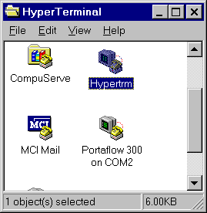

The heading Connection Description will appear after Hypertrm has been selected. Enter the name of your choice. Select OK when complete.
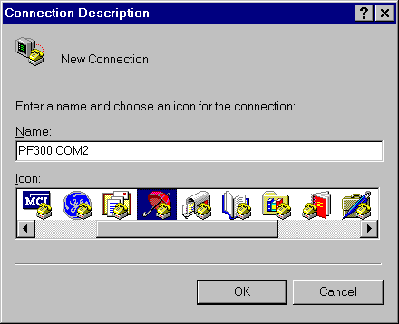

The heading Phone Number will appear.
Select Connect using: then Direct to Com 2. When this has been selected the heading Com 2 Properties will appear, select OK.
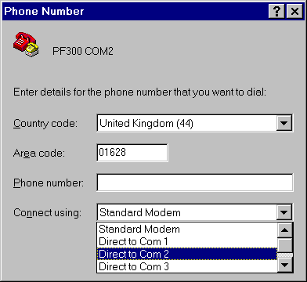

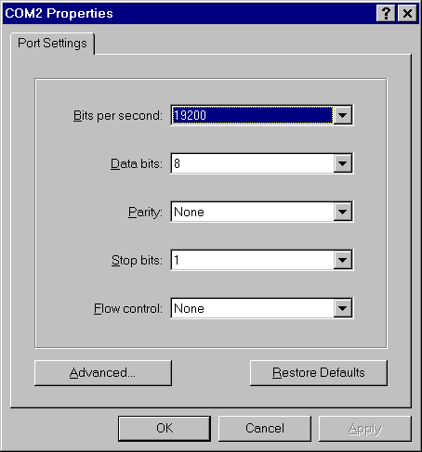

SET UP RS232 yy-mm-dd hh:mm:ss

Handshaking(flow control/Protocol) none
Baud rate(Bits per second) 19200
Data bits 8
Stop bits 1
Parity NONE
New line CR
Printer test
Exit

The Portaflow 300 can now be configured to the PC. Select Setup RS232 on the MAIN MENU and press ENTER. Change the settings on the computer to match those on the Portaflow 300 then exit the menu.

Downloading data to a spreadsheet in WINDOWS 95
Before downloading data onto a spreadsheet and Download range to RS232 is selected on the Portaflow 300, the data has to be stored to a file. Data cannot be entered onto a spreadsheet after Download to RS232 has been selected.

Select Transfer then Capture Text from the Hyper Terminal Window. The following will be displayed.
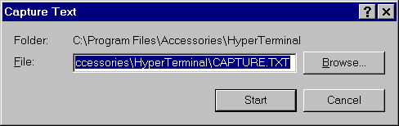

The data can be saved in any file or directory as a TEXT file. CAPTURE.TXT is a default name that can be changed. Make sure a new file name is given every time data is downloaded otherwise data is just added to the file of the same name. Press start. When entering a file name make sure .TXT is entered directly after the name given. Once the data is in the file you can leave the Hyper Terminal without having to save the data.

Now go to Excel and find the file name and enter it on a spreadsheet. The following will be displayed.
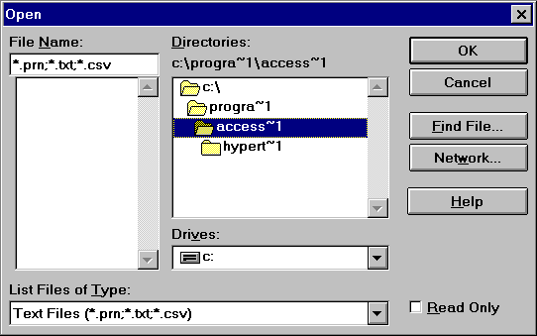

The following will be displayed, allowing the data to be set in a format for Excel.
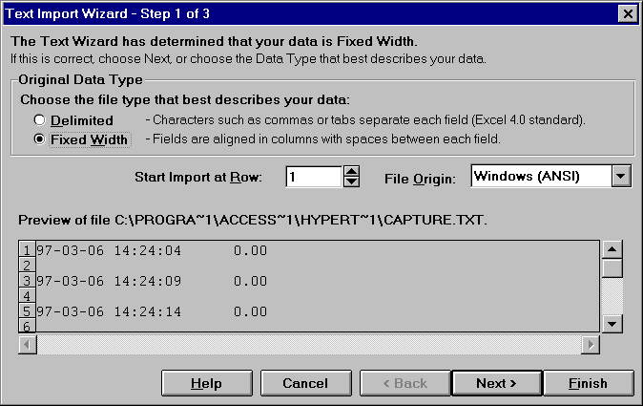

Complete the following 3 Steps in Text import wizard, then select Printer test on the Portaflow 300. The following will be displayed.
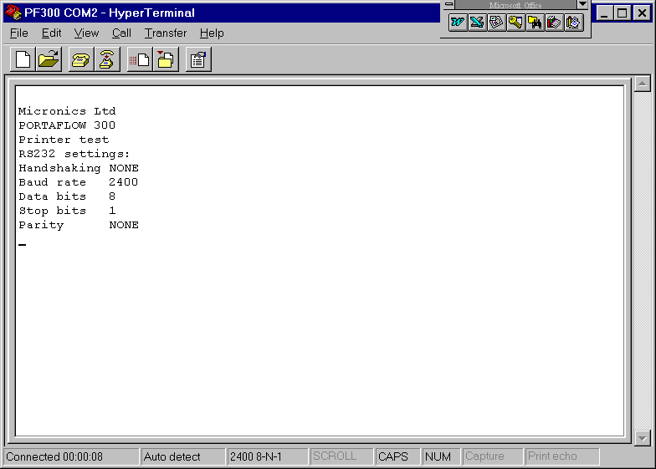

On the Portaflow 300 now select Main menu, ENTER > Data logger ENTER > Download log ENTER.

Select a range to download as described on page 11 and press ENTER to download the data.

Download Data To Windows 3.1
Before downloading data onto a spreadsheet and Download range to RS232 is selected on the Portaflow 300, the data has to be stored to a file. Data cannot be entered onto a spreadsheet unless it has been stored to a file.

Micronics suggest when downloading to a P.C. Handshaking > None is selected (See page 15 - Set Up RS232) when setting up the RS232.

Select Program Manager then Accessories.
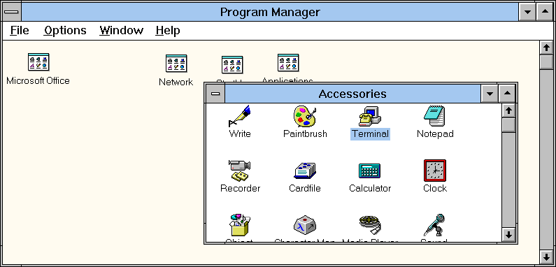

Now select Settings and Communications from the Terminal Window.
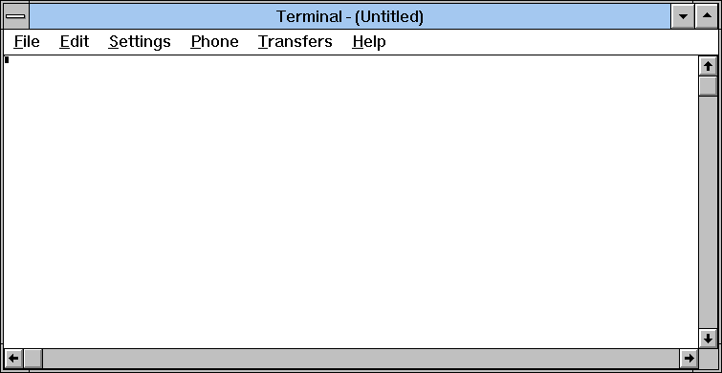

The following will be displayed.
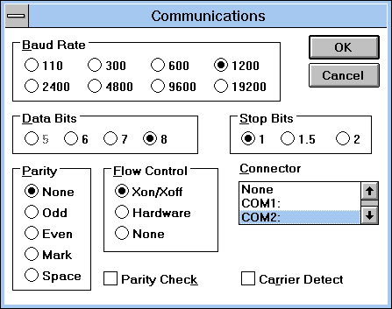
Note: Flow Control is also known as Handshaking or Protocol.

Check now that the above settings are the same as the settings on the Portaflow 300. This can be done from Read flow mode using the RS232 key or from the MAIN MENU and Set up RS232. If they are not set up correctly an error message will occur in Windows.

Downloading data to a spreadsheet in Windows 3.1
Select Transfer from the Terminal Window then Receive text file.

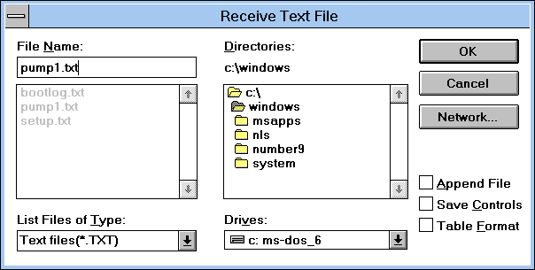

Select a name making sure .txt is entered immediately after it and select OK. Make a note of the file name for when you go into the spreadsheet.

Select a range to download on the Portaflow 300 as described on page 11 and press ENTER to download the data.

Pressing Download Range to RS232 on the Portaflow 300 will now display the following in the Terminal window. Press STOP when complete and escape.

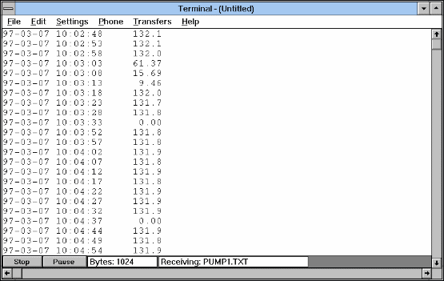

At this point you can go into the spreadsheet to find the file under a text format.

Example from Excel
By selecting OK at this point it is possible to follow the instructions in the Excel hand book.
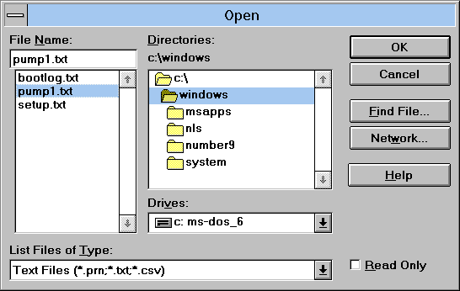

Main Menu - Set Up RS232
The RS232 must be configured to work with exactly the same parameters as the printer or computer that you connect it to. All options on this menu are stored when the instrument is switched off.

Selecting HANDSHAKING (also known as flow control or protocol) shows the following display.
Select using the scroll keys then press ENTER to confirm.
HANDSHAKING yy-mm-dd hh:mm:ss

NONE
Dtr/Dsr
Xon/ Xoff

Select using the scroll key then press ENTER to confirm.

Data bits, Stop bits, Parity and New line, scroll down these options in the SET UP RS232 and press ENTER to bring up selection. Scroll down the options and press ENTER to select.

Printer test displays or prints the settings to show a connection to the Portaflow 300.
Exit from RS232 returns user to MAIN MENU.
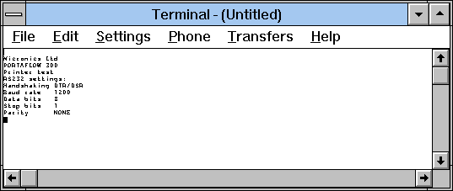

Main Menu - Set Up Portaflow

Set Date & Time
When the cursor bar is on Set date and time press ENTER, the display will show.

SETUP PORTAFLOW yy-mm-dd hh:mm:ss

Set date & time 99-01-01 09:30:31
Calibrate 4-20mA
Backlight Disabled
Application options
Sensor parameters
Factory settings
Exit menu

A cursor will be positioned on the month and start flashing. By using the scroll keys you can select the month and by taking the month forward or back past month 12 every time, increases or decreases the year. When the month and year have been selected press ENTER and follow the same procedure for the day. The same procedure is used in setting the time. When everything is set press ENTER and the instrument returns to the SETUP PORTAFLOW menu.

Calibrate 4-20mA (Note: A meter is required to measure the output.)
The 4-20mA is calibrated before it leaves the factory, but this option allows the user to adjust it if necessary to match a specific display. The DAC value is a number between 0 and 40,000 is a number internal to the Portaflow that will change when calibrating the 4-20mA.

The first stage is to adjust the output current to 4mA. When connected to any device that accepts 4-20mA, it may require adjustment to exactly 4mA or 20mA and this is possible by using the scroll keys or keys 5 and 6. The scroll keys move the DAC value in larger steps of 25 and keys 5 & 6 move the value one at a time.

The DAC value should be approximately 8000 for 4mA and 40000 for 20mA. Watching the actual current value displayed on the meter, it is possible to scroll up and down or use keys 5 and 6 to calibrate the 4-20mA to the exact value.

When the 4mA is adjusted press ENTER. If the 4-20mA is not connected then the instrument will still display the DAC number but display Error instead of OK.

CALIBRATE 4-20mA yy-mm-dd hh:mm:ss

Adjust the output current to 4mA
Use UP/DOWN to set, 5/6 to trim

DAC value: 8590 mA OK

Press ENTER when done

Now adjust the 20mA, press ENTER when complete and the display will return to the SETUP PORTAFLOW menu.
CALIBRATE 4-20mA yy-mm-dd hh:mm:ss

Adjust the output current to 20mA
Use UP/DOWN to set, 5/6 to trim

DAC value: 39900 mA OK

Press ENTER when done

If the load is not connected or too high ERROR will be displayed next to mA, as shown below.
CALIBRATE 4-20mA yy-mm-dd hh:mm:ss

Adjust the output current to 20mA
Use UP/DOWN to set, 5/6 to trim

DAC value: 39900 mA ERROR

Press ENTER when done

Backlight
Use the scroll key to select backlight and press ENTER.

SETUP PORTAFLOW yy-mm-dd hh:mm:ss

Set date & time yy-mm-dd hr-min-sec
Calibrate 4-20mA
Backlight Disabled
Application options
Sensor parameters
Factory settings
Exit menu
This allows the user to enable or disable the backlight. Use the scroll key to select and press ENTER.
Backlight yy-mm-dd hh:mm:ss

Enabled
Disabled

Application Options
Use the scroll key to select Application Options and press ENTER.

SETUP PORTAFLOW yy-mm-dd hh:mm:ss

Set date & time yy-mm-dd hr-min-sec
Calibrate 4-20mA
Backlight Disabled
Application options
Sensor parameters
Factory settings
Exit menu

Application Options
It is a facility that could enhance signals levels on difficult applications, primarily very small or very large pipes.

Sensor Parameters
This facility allows Micronics or the user to program the instrument to accept different sensor sets in the future and when they become available. Instructions for this are included for each new sensor.

The instrument is already programmed to use sensor set supplied.
SENSOR PARAMETERS yy-mm-dd hh:mm:ss

WARNING! Sensor should only be edited
following instructions from the factory
Enter password or press ENTER to quit

Factory Settings
This is not an option for the user but a facility for Micronics engineers to calibrate each instrument at the factory. Pressing ENTER in this mode takes the user back to the MAIN MENU.

Main Menu - Read Flow
100.0 l/m LPM
When choosing the Read flow option from the MAIN MENU the instrument reverts directly back to the data that was last entered. Therefore the instrument will have to be reprogrammed if it is to be used on a new application.
ATTACH SENSORS yy-mm-dd hh:mm:ss

Attach sensor set A in REFLEX mode

Approx. max. flow: 7.20 m/s

Press ENTER to continue
or SCROLL to select another sensor

Press ENTER now to make the instrument search for a temperature signal. If this is not found then the display will read the following.
ATTACH SENSORS yy-mm-dd hh:mm:ss

No signal from temp sensor

Press ENTER to try again or
SCROLL to enter a value

The user can now enter a temperature value between -20°C and +220°C, press ENTER for the separation distance.

The display will now read the following. The temperature will only be shown on this display if entered manually.
ATTACH SENSORS yy-mm-dd hh:mm:ss

FLUID TEMPERATURE (°C) 20.0

Set sensor separation to 33.5

Press ENTER to continue

Now set the transducers to the separation distance. Pressing ENTER will take the instrument into flow mode.
READ FLOW yy-mm-dd hh:mm:ss
ERROR MESSAGES APPEAR HERE
Battery
100%
Signal
100%
Temp + Total 1564 l
20°C - Total l

KEYPAD OPTIONS
The output options can only be adjusted/operated in flow mode.

Logger Key
The data logger can only be set up from flow mode and is accessed via the keypad. Once the logger is recording only some parameters can be changed.

By pressing the logger key the display will read the following.

DATA LOGGER yy-mm-dd hh:mm:ss

Log name QUICK START
Log data to MEMORY
Logging interval 5 seconds
START NOW
Start time 97-01-22 00:00:00
Stop time 97-01-25 00:00:00
Memory free 50000
List block names
Next block to view
View log as text
View log as graph
Units l/m
Graph Y axis max. 3450
Clear log
Exit

Log Name
This allows the user to give the data that is going to be logged, a name. The name will be displayed at the start of each block of memory until the instrument has stopped logging.
EDIT LOG NAME yy-mm-dd hh:mm:ss

Use SCROLL to choose, ENTER to select,
- for SPACE, DELETE to clear, 0 to end

abcdefghijklmnopqrstuvwxyz0123456789

>...........................<

Log Data To
Selecting this option gives the user the choice of logging to the memory, RS232 or both. Select the option required by using the scroll keys and press ENTER (See also Downloading to Windows pages 12 and 14).

Logging Interval
This option displays a range of times that allow the user to decide how often the readings need to be logged. The times range from 5 seconds to 1 hour. Use the scroll keys to select then press ENTER.

Start/Stop Now
This starts and stops the logger immediately. When Start now is displayed press ENTER to start, the display will change to Stop now. When Stop now is displayed press ENTER to stop, the display will change to Start now. This function defaults the logger to 1 hour of logging. If a longer period of logging is required then the Start/Stop time will have to be set up.

Start/Stop Time
This allows the user to program a time for the logger to start and stop logging in advance of going on site. Press ENTER to select and program as per the instructions for setting time and date on page 15 – Set up Portaflow.

Note: Memory free, List block names, Next block to view, View log as text, View log as graph, Units, Graph Y axis max, Clear log and Exit are the same as described on page 10 - Main Menu - Data Logger

4 - 20mA Output KEY
The 4-20mA can be set to the maximum flow rate. It is also possible to enter a negative figure for the minimum output and would enable a reverse flow to be monitored. The 4mA would then be the maximum reverse flow (e.g. -100 lpm) and the 20mA would be a maximum positive flow (e.g. 100 lpm).

mA Out
This displays what the current output is giving at any particular time.
4 - 20MA yy-mm-dd hh:mm:ss

mA out 0.00
Output OFF
Units m/s
Flow at max output 3171
Flow at min output 0.00
Output mA for error 22
Exit

Output
This option allows the user to select between three different outputs or switching the output off. The display will read as follows.
Scroll down the options to select required output, and press ENTER. The display will then revert back to the 4-20mA menu and Flow at max output.

OUTPUT yy-mm-dd hh:mm:ss

OFF
4 - 20mA
0 - 20mA
0 - 16mA

Units
The flow units can be changed at this stage by selecting them from the keypad. When selected, scroll down to move onto the next option.

Flow at Max Output
This sets the output at the top end of the scale so that the maximum flow gives 20mA (or 16mA).

The instrument automatically defaults to the maximum flow rate, but by pressing ENTER the user can scale the output to any level required. When selected press ENTER to continue.

If the flow was to go over the maximum range set, the instrument will go to a maximum of 24.4 mA and stay there until either the flow reduces or the output is re-scaled. The instrument will also display a warning message - mA out over range- if the output is greater than 20mA or 16mA,

Flow at Min. Output
This sets the output at the bottom end of the scale so that the minimum flow gives 4mA or 0mA.

The instrument automatically defaults to zero and the user is able to enter any figure they wish including a minus figure for reverse flow conditions.

Output mA For Error
This gives an error and which would inform the user of loss of signal. This can be set to any figure between zero and 24mA, but defaults to 22mA.

Exit

RS232 Output Key
This is set up in exactly the same way as when the RS232 is set up from the MAIN MENU (See page 15).

Delete Key
If anything is entered in error, press the DELETE key and re-enter the information required.

Pulse Output Key
This can only be operated in flow mode.
Use the scroll key to move the cursor up or down the display. To change the flow units press the key required. This will also change the flow units when returning to the flow mode. Changing the flow units will also re-scale the litres per pulse.
PULSE OUTPUT yy-mm-dd hh:mm:ss

Flow units
Output OFF
Max. pulse rate1 per sec
Litres per pulse12.76
Exit

Outputs allow the user to select from the following.
Selecting Off switches the pulse off and returns to the PULSE OUTPUT display.
Selecting the Forward total counts the pulses of the forward flow only.
Selecting Net total counts the pulses of the sum of the forward total less the reverse total.

OUTPUT yy-mm-dd hh:mm:ss

Off
Forward total
Net total

Max. Pulse Rate
This option allows the user to select between fast/slow pulses or large/small pulse width. Select 1 per second for slow pulses and 100 for a fast pulse. The pulse width for 1 per second is 100ms and 5ms for 100 per second.

XXXX per pulse
This will change when the flow units are changed above. When the correct flow units are selected this allows the user to scale the pulses to there own requirements or it can be left in the default setting.

Options Key
This can only be used in flow mode. Scroll down the options then press ENTER to select.

OPTIONS yy-mm-dd hh:mm:ss

Zero cut off (m/s) 0.01
Set zero flow
Total RUN/STALL
Reset + total
Reset - total
Damping (sec) 5
Calibration factor 1.000
Correction factor 1.000 Diagnostics
Exit

Zero Cut Off (m/s)
The instrument has an automatic ZERO CUTOFF that is calculated to 0.05 m/s. The maximum flow is calculated when the instrument is programmed and is displayed when sensor set and mode of operation are displayed (See page 9 - Read Flow - Attach sensors). Micronics cannot guarantee measuring flows below this range, due to instabilities in the measurement system, but it is possible for the user to cancel any cut-off altogether.

This also allows the user to not see or record any flow that they may not want to. For example it may be that the user may not want to measure flows below 50 LPM in a 50mm pipe, which is equivalent to 0.42 m/sec, in which case 0.42 m/sec would be entered into the instrument, and nothing would be recorded below that level. The maximum cut off 1 m/sec.
Set Zero Flow
On some applications and in some conditions it may be that although there is no flow the instrument may show a small offset due to picking up noise. This is an offset that can be cancelled out and will increase the accuracy of the instrument. By selecting this option and pressing ENTER the display will show the following.
SET ZERO FLOW yy-mm-dd hh:mm:ss

Stop the flow COMPLETELY and then
press ENTER

Press SCROLL to cancel

Pressing ENTER before the flow has stopped will result in an error message which asks are you sure the flow has stopped. This occurs when the flow is still above 0.25m/sec.

When this option has already been selected, press ENTER to cancel the previous instruction, then it is possible to re-set the Zero balance.

This option is not available when error messages E1 and E2 (See page 21) are being displayed.

Total-RUN/STALL
OPTIONS yy-mm-dd hh:mm:ss

Zero cut off (m/s) 0.01
Set zero flow
Total RUN/STALL
Reset + total
Reset - total
Damping (sec) 5
Calibration factor 1.000
Correction factor 1.000 Diagnostics
Exit

This option allows the user to STALL/RUN the total for volumetric checks. Firstly you must press STALL before resetting both totals. Select Total, STALL then press ENTER. This will then take you back to the previous screen. Now reset the totals. When the totals have been reset, scroll back to Total – STALL and press enter. The total will stay at zero until RUN is selected and ENTER is pressed. To then stop the total select Total as shown above press ENTER, scroll down to STALL and press ENTER again.

Reset + Total/- Total
The Portaflow 300 has forward and reverse totalisers that can be reset when this option is selected. Use the scroll keys to select then press ENTER to reset. The Total is stored when unit is switched off or the battery discharges.

Damping (sec)
This option is used when the flow readings are unstable due to turbulence caused by obstructions or bends etc. Damping or averaging can be used to make the readings more stable. It can be set to up-date the display, anything between 3 and 100 seconds.

Calibration Factor
This facility should not need to be used in general use. One reason could be that a guide rail was being used that had not been calibrated with the instrument and had been supplied as a spare. This could cause the instrument to be out of calibration.

If for any reason the instrument goes out of calibration and the readings may be higher or lower than normal then this facility enables the user to correct the reading. If for example the reading is 4% higher than normal then entering 0.96 will reduce the reading by 4%. If the reading were 4% lower than normal then entering 1.04 would increase the reading by 4%.

When the instrument is supplied it will always default to 1.00 and when this is changed it will stay in the memory to whatever it has been changed to, until such time as it needs to be changed again.

Correction Factor
This is a facility that can be used when errors occur due to lack of straight pipe or the sensors have been placed too close to a bend, this could give an incorrect reading to what is expected. The user can set this as a % in the same way as the calibration factor, but it will not be stored in the memory.

Diagnostics

Calculated μs
This is a value the instrument predicts will be the time in μsecs that it should take for the transmitted signal to go across a particular pipe size. This value is ascertained from the data entered by the user. i.e. Pipe size, material, sensor set etc.

Up μs, Dn μs
This is the actual transit time measured by the instrument and will be slightly (5-10μs depending on the pipe size and signal condition) less than the calculated value above.

Measurement μs
This is a point in the signal transmitted, where the flow measurement is taken from. It is used to see if the signal is being taken from the burst, at the correct time to get the strongest signal. This is normally used on smaller pipes when the instrument is being used in double or triple bounce were signals can sometimes interfere with each other. This value is normally a few μs below the Up μs, Dn μs value.

Phase up/dn μs
This is only valid if Calculated μs and Up μs, Dn μs are correct. If the reading is zero then there is no signal, which could mean the pipe is empty, or the liquid is contaminated with particles or air.

Phase offset
This value will be between 0 and 15. The exact value is not important and will vary between applications. It should however, be stable when the flow condition is good and velocity is within the range of the transducers being used. As the flow rate increases towards and beyond the maximum, this figure will continuously change. In flow mode the instrument will read unstable or high flow.

Flow (m/s)
This displays flow velocity in m/sec to 3 decimal places.

Signal
This is the averaged value of Signal up/dn and is a value between 800 and 2400. The display shows the signal strength as a percentage (800=0%, 2400=100%).

Signal up/dn
This value is in mV the maximum value being limited by the electronics to 2200, but must be greater than 800. There is an option in the SET UP PORTAFLOW menu to allow this value to be taken down to 400 in extreme circumstances. This is useful on some applications when the signal levels are poor.

Prop μs
This is the actual time for the signal to traverse the block, pipe wall, fluid and back again. It is proportional to the pipe size and temperature of the liquid.

Prop signal
This will be a value between 800 and 2200 as in Signal up/dn, above but not the same value.

Fluid prop rate
This is the sound speed of the fluid calculated using the data entered by the user and the prop measurement. This value may be subject to errors due to small pipe dimension errors especially on smaller pipes. Micronics recommend the use of tabulated values (See page 27).

Sensor separation
Displayed to indicate the distance to set the transducers on the pipe.

STATUS/ERROR/WARNING MESSAGES
There are three types of message that will appear and they are Status, Error and Warning. These messages appear under the time and date on the display when in flow mode.

Status Messages

S1: INITIALISING
Appears when first entering flow mode to show instrument is starting up.

S2: LOGGING TO MEMORY
This informs the user that the instrument is logging to the internal memory.

S3: LOGGING TO RS232
This informs the user that the instrument is logging to an external device i.e. a printer.

Error Messages

E1: UNSTABLE OR HIGH FLOW
This error message occurs when either the sensors have been positioned too near to an obstruction or bend causing turbulence, or the instrument is being used outside its normal flow range.

When the instrument is programmed the user is informed of the maximum flow rate that is possible to measure and if this is exceeded then the high flow message occurs.

It may be possible to get round these problems by moving the sensors to a straighter length of pipe or in the case of high flows another set of transducers may be used.

E2: NO FLOW SIGNAL
This message appears when the two transducers cannot send or receive signals, which could happen for various reasons. Firstly check that all cables are connected, transducers are on the pipe correctly with grease on the face.

These reasons could be when trying to measure a partially empty pipe, aerated liquid or when the particulate content of that liquid is too high. It could also happen if couplant has not been applied to the transducers or the condition of the pipe being measured is poor.

Warning Messages

W1: CHECK SITE DATA
This message occurs when the application information has been entered incorrectly and the wrong sensors have been attached to the wrong pipe size causing the timing to be in error. The site data needs to be checked and the instrument reprogrammed.

W2: SIGNAL TIMING POOR
Unstable signal timing or differing up/down stream times indicate that the liquid is aerated or pipe surface is of poor quality.

W3: NO PROP SIGNAL
This occurs when the fixed transducer is unable to transmit and receive a signal across the pipe, for the same reasons as explained in E2. The instrument is capable of measuring the sound propagation rate of the liquid (See page 26). The message will only appear when the user has asked the instrument to make this measurement and not when a fluid type has been selected from the list or the black sensor cable is not connected.

W4: RS232 NOT READY
This occurs when the equipment that is connected to the Portaflow 300 via the RS232 is off line. Check that the connections to ancillary equipment have been switched on.

W5: LOG MEMORY FULL
This occurs when all memory blocks in the 112K built data logger have been used up. (To clear the memory see page 12).

W6: FLOW SIGNALS POOR
This warning appears when there is a signal lower than 25%. This could be due to the application, a poor quality pipe, amongst others.

W7: mA OUT OVERANGE
The mA output is over-range when the flow is higher than the maximum mA range. Once the
4-20mA is set up and the flow goes above the range set then this message will appear. It is possible to re-scale the 4-20mA to be able to cope with the higher flow.

W8: PULSES AT MAXIMUM
This message occurs when the pulses have been set up and the flow is higher than the maximum that has been set. It is possible to be able to re-scale the pulse output to cope with the higher flow.

W9: BATTERY LOW
The battery low warning occurs when battery indication is on 20%. This leaves the instrument with approximately 30 minutes usage before it needs recharging.

W10: NO TEMP SIGNAL
Inside the transducer block is a temperature sensor that monitors the application temperature. When it is not connected between the electronics and the sensor, then the above error message is displayed.

W11: mA LOAD TO HIGH
The 4-20mA is designed to work with a load up to 750Ω. When the load is too high or not connected, the above warning message will be displayed.

Other Messages
The messages below appear mainly when data has been incorrectly entered or the Portaflow 300 is trying to be used on an application that it is not capable of working on.

Pipe OD out of range
The outside diameter of the pipe has been entered and is out of range of the instrument.

Wall thickness out of range
The wall thickness that has been entered is out of range of the instrument.

No data exists for this sensor
A sensor has been selected that is not available for use.

Lining thickness out of range
The pipe lining thickness has been incorrectly entered.

Site range is 0 - 20
There are only 20 storage sites available with 0 being the QUICK START site.

- CANNOT READ FLOW BECAUSE…
…. Pipe dimensions are invalid

- CANNOT READ FLOW BECAUSE …materials are invalid

- CANNOT READ FLOW BECAUSE
…Pipe is too large for sensor set

- CANNOT READ FLOW BECAUSE
…. Pipe is too small for sensor set

- CANNOT READ FLOW BECAUSE

…Sensor mode is invalid for this pipe size

Temperature range is -20°C to +200°C
The temperature range of the transducers is -20°C to +200°C.

Logging has started
This will only appear if the instrument has been supplied with a logger.

Enter a lining thickness first
This message appears when in VIEW/EDIT SITE DATA the user has tried to enter a pipe lining material before entering a thickness.

APPLICATION INFORMATION
The PORTAFLOW 300 is a Transit Time ultrasonic flow meter. It has been designed to work with Clamp On transducers, thus enabling liquid flowing within a closed pipe to be measured accurately without the need for any mechanical parts to be inserted either through the pipe wall or protrude into the flow system.

The meter is controlled by a micro-processor containing a wide range of data which enables the instrument to measure flow in any pipe diameter from 13mm bore up to 5000mm, made of any material and over a wide range of operating temperatures.

The system operates as follows:
Figure 12
Reflex mode
propagation rate crystal

‘A’
‘B’

FLOW

Reflex mode - double bounce
propagation rate crystal

‘A’
‘B’

FLOW

Reflex mode - triple bounce
propagation rate crystal

‘A’
‘B’
FLOW

Diagonal mode
propagation rate crystal

‘A’

FLOW

‘B’

When ultrasound is transmitted from Transducer ‘A’ to Transducer ‘B’ (REFLEX MODE) or Transducer ‘A’ to ‘C’ (DIAGONAL MODE) the speed at which the sound travels through the liquid is accelerated slightly by the velocity of the liquid. If sound is transmitted in the opposite direction from ‘B’ to ‘A’ or ‘C’ to ‘A’, it is decelerated because it is travelling against the flow of the liquid. The differences in time taken to travel the same distance but in opposite directions are directly proportional to the flow velocity of the liquid.

Having measured the flow velocity and knowing the pipe cross-sectional area, the volumetric flow can be easily calculated. All of the calculations required to first determine the correct alignment of the transducers and subsequently compute the actual flow are carried out by the microprocessor.

To measure flow, it is first necessary to obtain detailed information about each application, which is then programmed into the processor via the Key Pad. This information must be accurate otherwise flow measurement errors will occur.

Further, having calculated the precise position at which the transducers must be clamped onto the pipe wall, it is equally important to align and separate the transducers accurately with respect to one another, as failing to do so will again cause errors in measurement.

Finally, to ensure accurate flow measurement it is imperative that the liquid is flowing uniformly within the pipe and that the flow profile has not been distorted by any upstream or downstream obstructions.

To obtain the best results from the Portaflow 300 it is absolutely necessary that the following rules for positioning the transducers are adhered to and that the condition of the liquid and the pipe wall are suitable to allow transmission of the sound along its predetermined path.

TRANSDUCER POSITIONING
As the transducers for the Portaflow 300 are clamped to the outside surface of the pipe, the meter has no way of determining exactly what is happening to the liquid. The assumption therefore has to be made that the liquid is flowing uniformly along the pipe either under fully turbulent conditions or under laminar flow conditions. Further it is assumed that the flow velocity profile is uniform for 360° around the pipe axis.

Figure 13 - A uniform profile as compared to a distorted profile.
TOP
BOTTOM
INCORRECT
TOP
BOTTOM
CORRECT

The difference between (a) and (b) is that the Mean Velocity of the flow across the pipe is different and because the Portaflow 300 expects a uniform flow as in (a), the distorted flow as in (b) will give measurement errors which cannot be predicted or compensated for.
Flow profile distortions result from upstream disturbances such as bends, tees, valves, pumps and other similar obstructions.

To ensure a uniform profile the transducers must be mounted far enough away from any cause of distortion such that it no longer has an effect.

Figure 14
INCORRECT
> 20 D
FLOW
CORRECT
FLOW
FLOW

10 D
20D
FLOW

5 D
20D
< 20 D

The minimum length of upstream straight pipe is 20 Diameters and 10 Diameters downstream to ensure accurate results will be achieved.
Flow measurements can be made on shorter lengths of straight pipe down to 10 Diameters upstream and 5 Diameters downstream, but when the transducers are sighted this close to any obstruction errors can be considerable.

It is not possible to predict the amount of error as this depends entirely upon the type of obstruction and the configuration of the pipework.

The message therefore is clear: Do not expect to obtain accurate results if the transducers are positioned closer than allowed to any obstruction that distorts the uniformity of the flow profile.

MOUNTING THE TRANSDUCERS
It will be impossible to achieve the accuracy of measurement specified for the Portaflow 300 if the transducers are not clamped to the pipe correctly and if the data - I.D. O.D., Pipe Material - are not accurate.

Apart from the correct positioning and alignment of the transducers, of equal importance is the condition of the pipe surface in the area under each of the transducers.

An uneven surface that prevents the transducers from sitting flat on the surface of the pipe can cause Signal Level and Zero Offset problems. The following procedure is offered as a guide to good practice with respect to positioning and mounting the transducers.

1) Select the site following the rules on page 23 - Transducer Positioning.

2) Inspect the surface of the pipe to ensure it is free from rust or is not uneven for any reason. Transducers can be mounted directly on painted surfaces as long as the surface is smooth and that the underlying metal surface is free from rust bubbles. On bitumen or rubber coated pipes the coating must be removed in the area under the transducers as they should be mounted directly on to the base metal.

- Transducers can be mounted on both Vertical and Horizontal Pipe Runs.

- Apply Interface couplant to the face of the transducers. The amount of couplant used is extremely important particularly on pipes of less than 89mm bore.

Figure 15
For all small pipes below 89mm, using 2MHz transducers, the bead of couplant used must be approximately 20mm long and 2mm maximum diameter for the moveable sensor and 30 long and 2mm diameter for the fixed sensor. Using more couplant could cause wall signals to be generated which cause errors in measurement.

On Stainless Steel Pipes the amount of couplant applied should never exceed the amount indicated on page 3. On large Plastic and Steel Pipes the amount of couplant applied is less critical, however do not use more than is absolutely necessary.

Transducer set ‘B’ and ‘C’.The main difference between transducer set ‘B’ and ‘C’ is the angle that the crystal has been inserted in the sensor block itself. The maximum amount of couplant required is a bead 30mm long by 5mm wide.

Figure 16

Figure 17 - Transducer set ‘D’
The two 0.5 MHz transducer blocks are the same, there is no propagation rate measurement required when using transducer set ‘D’.
Figure 18
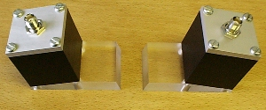

5) Strap the guide rail assembly to the pipe so that it is perfectly parallel to the pipe axis.
6) When screwing the transducers on to the pipe surface use only enough force to ensure that the Transducer is flat against the pipe surface and then lock in position.
7) Clamping the transducers in exactly the correct position is extremely important. The Separation Distance is calculated by the Portaflow 300 electronics and the transducers must be positioned and clamped exactly at the distance specified.
8) Always use the couplant provided.

LIQUID CONDITIONS
Transit time ultrasonic meters perform best on liquids that are totally free from entrained air and solids. With sufficient air in the system the ultrasound beam can be attenuated totally and therefore prevent the instrument from working.

Often it is possible to tell whether there is air in the system or not. If a flow signal cannot be obtained a simple test to determine whether the flow is aerated involves stopping the flow for a period of 10 - 15 minutes. During this time the air bubbles will rise to the top of the pipe and the flow signal should return.
If the flow signal does return switch on the flow and if sufficient entrained air is locked in the system it will very quickly disperse and kill the signal.

REYNOLDS NUMBER
The Portaflow 300 has been calibrated to operate on Turbulent flows with a Reynolds No. of 100,000. When the Reynolds Number decreases to 4000-5000 the instrument calibration is no longer valid.

If the Portaflow 300 is to be used on laminar flow applications it will be necessary to calculate the Reynolds No. When calculating the Reynolds No. it is necessary to know the Kinematic viscosity in Centistokes; the flow velocity and the pipe inside diameter.
To calculate 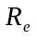 use the following formula: -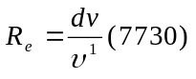 or 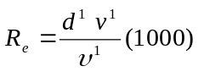
Where
= inside pipe diameter in inches
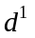= inside pipe diameter in millimetres
= velocity in feet/second
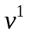= velocity in metres/second
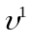= Kinematic viscosity in centistokes

To correct the Portaflow 300 for operation in
laminar flow region, calculate the Reynolds No
and adjust the correction factor.

PROPAGATION VELOCITY
To make a flow measurement using the Portaflow 300 on any liquid, it is necessary to know the propagation velocity in metres/second. There is a short list of fluids that appear on the display when programming (See page 7), showing water and various other liquids. However if the liquid you wish to measure is not on this list, by selecting measure, the instrument measures the propagation rate itself and by selecting Other it is possible to enter the propagation rate in m/sec, if known.

MAXIMUM FLOW
The maximum flow is dependent on the velocity and pipe size.

APPLICATION TEMPERATURE
On any application where the operating temperature is either above or below ambient ensure that the transducers reach and are maintained at the application temperature before undertaking a measurement.

Transducer sets ‘A’, ‘B’ and ‘C’ have a builtin temperature sensor inside the block that needs to reach the application temperature before making a measurement. If the block is not up to application temperature it could affect the separation distance and therefore the accuracy.

When applying the transducers to low temperature applications do not allow the pipe surface to ice up between the transducer and the pipe wall. The ice will force the block away from the pipe wall and consequently you will lose the signal.

FLOW RANGE
Figure 19
Transducer Set ‘A’
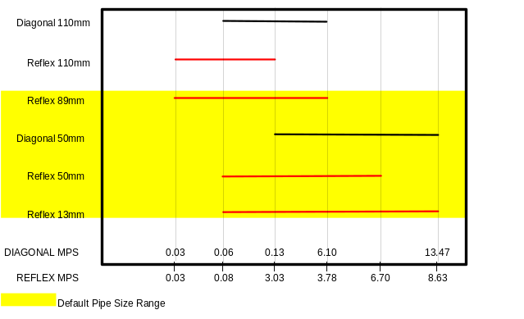
Transducer Set ‘B’
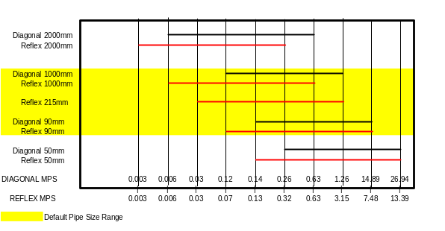

Transducer Set ‘C’
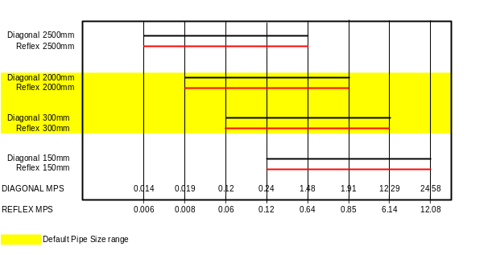

Transducer Set ‘D’
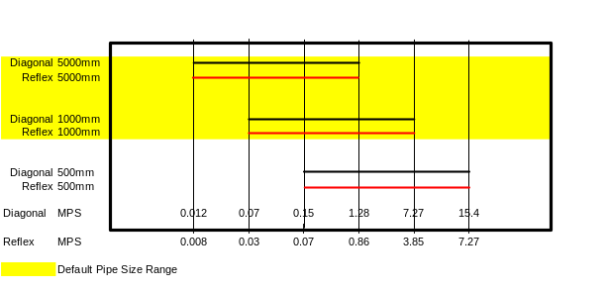

Liquid Sound Speeds at 25°C
Substance | Form Index | Specific Gravity | Sound Speed | Δv/ºC -m/s/ºC
Acetic anhydride (22) | (CH₃CO)₂O | 1.082 (20ºC) | 1180 | 2.5
Acetic acid, anhydride (22) | (CH₃CO)₂O | 1.082 (20ºC) | 1180 | 2.5
Acetic acid, nitrile | C₂H₃N | 0.783 | 1290 | 4.1
Acetic acid, ethyl ester (33) | C₄H₈O₂ | 0.901 | 1085 | 4.4
Acetic acid, methyl ester | C₃H₆O₂ | 0.934 | 1211
Acetone | C₃H₆O | 0.791 | 1174 | 4.5
Acetonitrile | C₂H₃N | 0.783 | 1290 | 4.1
Acetonylacetone | C₆H₁₀O₂ | 0.729 | 1399 | 3.6
Acetylene dichloride | C₂H₂C_{l2} | 1.26 | 1015 | 3.8
Acetylene tetrabromide (47) | C₂H₂Br₄ | 2.966 | 1027
Acetylene tetrachloride (47) | C₂H₂Cl₄ | 1.595 | 1147
Alcohol | C₂H₆O | 0.789 | 1207 | 4.0
Alkazene-13 | C₁₅H₂₄ | 0.86 | 1317 | 3.9
Alkazene-25 | C₁₀H₁₂Cl₂ | 1.20 | 1307 | 3.4
2-Amino-ethanol | C₂H₇NO | 1.018 | 1724 | 3.4
2-Aminotolidine (46) | C₇H₉N | 0.999 (20ºC) | 1618
4-Aminotolidine (46) | C₇H₉N | 0.966 (45ºC) | 1480
Ammonia (35) | NH₃ | 0.771 | 1729 | 6.68
Amorphous Polyolefin |  | 0.98 | 962.6
t-Amyl alcohol | C₅H₁₂O | 0.81 | 1204
Aminobenzene (41) | C₆H₅NO₂ | 1.022 | 1639 | 4.0
Aniline (41) | C₆H₅NO₂ | 1.022 | 1639 | 4.0
Argon (45) | Ar | 1.400 (-188ºC) | 853
Azine | C₆H₅N | 0.982 | 1415 | 4.1
Benzene (29,40,41) | C₆H₆ | 0.879 | 1306 | 4.65
Benzol (29,40,41) | C₆H₆ | 0.879 | 1306 | 4.65
Bromine (21) | Br₂ | 2.928 | 889 | 3.0
Bromo-benzene (46) | C₆H₅Br | 1.522 | 1170
1-Bromo-butane (46) | C₄H₉Br | 1.276 (20ºC) | 1019
Bromo-ethane (46) | C₂H₅Br | 1.460 (20ºC) | 900
Bromoform (46,47) | CHBr₃ | 2.89 (20ºC) | 918 | 3.1
n-Butane (2) | C₄H₁₀ | 0.601 (0ºC) | 1085 | 5.8
2-Butanol | C₄H₁₀O | 0.81 | 1240 | 3.3
sec-Butylalcohol | C₄H₁₀O | 0.81 | 1240 | 3.3
n-Butyl bromide (46) | C₄H₉Br | 1.276 (20ºC) | 1019
n-Butyl chloride (22,46) | C₄H₉Cl | 0.887 | 1140 | 4.57
tert Butyl chloride | C₄H₉Cl | 0.84 | 984 | 4.2
Butyl oleate | C₂₂H₄₂O₂ |  | 1404 | 3.0
2,3 Butylene glycol | C₄H₁₀O₂ | 1.019 | 1484 | 1.51
Cadmium (7) | Cd |  | 2237.7
Carbinol (40,41) | CH₄O | 0.791 (20ºC) | 1076 | 2.92
Carbitol | C₆H₁₄O₃ | 0.988 | 1458
Carbon dioxide (26) | CO₂ | 1.101 (-37ºC) | 839 | 7.71
Carbon disulphide | CS₂ | 1.261 (22ºC) | 1149
Carbon tetrachloride(33,35,47) | CCl₄ | 1.595 (20ºC) | 926 | 2.48
Carbon tetrafluoride (14) | CF₄ | 1.75 (-150ºC) | 875.2 | 6.61
Cetane (23) | C₁₆H₃₄ | 0.773 (20ºC) | 1338 | 3.71
Chloro-benezene | C₆H₅Cl | 1.106 | 1273 | 3.6
1-Chloro-butane (22,46) | C₄H₉Cl | 0.887 | 1140 | 4.57
Chloro-diFluoromethane (3) (Freon 22) | CHClF₂ | 1.491 (-69ºC) | 893.9 | 4.79
Chloroform (47) | CHCl₃ | 1.489 | 979 | 3.4
1-Chloro-propane (47) | C₃H₇Cl | 0.892 | 1058
Chlorotrifluoromethane (5) | CClF₃ |  | 724 | 5.26
Cinnamaldehyde | C₉H₈O | 1.112 | 1554 | 3.2
Cinnamic aldehyde | C₉H₈O | 1.112 | 1554 | 3.2
Colamine | C₂H₇NO | 1.018 | 1724 | 3.4
o-Cresol (46) | C₇H₈O | 1.047 (20ºC) | 1541
m-Cresol (46) | C₇H₈O | 1.034 (20ºC) | 1500
Cyanomethane | C₂H₃N | 0.783 | 1290 | 4.1
Cyclohexane (15) | C₆H₁₂ | 0.779 (20ºC) | 1248 | 5.41
Cyclohexanol | C₆H₁₂O | 0.962 | 1454 | 3.6
Cyclohexanone | C₆H₁₀O | 0.948 | 1423 | 4.0
Decane (46) | C₁₀H₂₂ | 0.730 | 1252
1-Decene (27) | C₁₀H₂₀ | 0.746 | 1235 | 4.0
n-Decylene (27) | C₁₀ H₂₀ | 0.746 | 1235 | 4.0
Diacetyl | C₄H₆O₂ | 0.99 | 1236 | 4.6
Diamylamine | C₁₀H₂₃N |  | 1256 | 3.9
1,2 Dibromo-ethane (47) | C₂H₄Br₂ | 2.18 | 995
trans-1,2-Dibromoethene(47) | C₂H₂Br₂ | 2.231 | 935
Dibutyl phthalate | C₈H₂₂O₄ |  | 1408
Dichloro-t-butyl alcohol | C₄H₈Cl₂O |  | 1304 | 3.8
2,3 Dichlorodioxane | C₂H₆Cl₂O₂ |  | 1391 | 3.7
Dichlorodifluoromethane (3) (Freon 12) | CCl₂F₂ | 1.516 (-40ºC) | 774.1 | 4.24
1,2 Dichloro ethane (47) | C₂H₄Cl₂ | 1.253 | 1193
cis 1,2-Dichloro-Ethene(3,47) | C₂H₂Cl₂ | 1.284 | 1061
trans 1,2-Dichloro-ethene(3,47) | C₂H₂Cl₂ | 1.257 | 1010
Dichloro-fluoromethane (3) (Freon 21) | CHCl₂F | 1.426 (0ºC) | 891 | 3.97
1-2-Dichlorohexafluoro cyclobutane (47) | C₄Cl₂F₆ | 1.654 | 669
1-3-Dichloro-isobutane | C₄H₈Cl₂ | 1.14 | 1220 | 3.4
Dichloro methane (3) | CH₂Cl₂ | 1.327 | 1070 | 3.94
1,1-Dichloro-1,2,2,2 tetra fluoroethane | CClF₂-CClF₂ | 1.455 | 665.3 | 3.73
Diethyl ether | C₄H₁₀O | 0.713 | 985 | 4.87
Diethylene glycol, monoethyl ether | C₆H₁₄O₃ | 0.988 | 1458
Diethylenimide oxide | C₄H₉NO | 1.00 | 1442 | 3.8
1,2-bis(DiFluoramino) butane (43) | C₄H₈(NF₂)₂ | 1.216 | 1000
1,2bis(DiFluoramino)- 2-methylpropane (43) | C₄H₉(NF₂)₂ | 1.213 | 900
1,2bis(DiFluoramino) propane (43) | C₃H₆(NF₂)₂ | 1.265 | 960
2,2bis(DiFluoramino) propane (43) | C₃H₆(NF₂)₂ | 1.254 | 890
2,2-Dihydroxydiethyl ether | C₄H₁₀O₃ | 1.116 | 1586 | 2.4
Dihydroxyethane | C₂H₆O₂ | 1.113 | 1658 | 2.1
1,3-Dimethyl-benzene (46) | C₈H₁₀ | 0.868 (15ºC) | 1343
1,2-Dimethyl-benzene(29,46) | C₈H₁₀ | 0.897 (20ºC) | 1331.5 | 4.1
1,4-Dimethyl-benzene (46) | C₈H₁₀ |  | 1334
2,2-Dimethyl-butane (29,33) | C₆H₁₄ | 0.649 (20ºC) | 1079
Dimethyl ketone | C₃H₆O | 0.791 | 1174 | 4.5
Dimethyl pentane (47) | C₇H₁₆ | 0.674 | 1063
Dimethyl phthalate | C₈H₁₀O₄ | 1.2 | 1463
Diiodo-methane | CH₂I₂ | 3.235 | 980
Dioxane | C₄H₈O₂ | 1.033 | 1376
Dodecane (23) | C₁₂H₂₆ | 0.749 | 1279 | 3.85
1,2-Ethanediol | C₂H₆O₂ | 1.113 | 1658 | 2.1
Ethanenitrile | C₂H₃N | 0.783 | 1290
Ethanoic anhydride (22) | (CH₃CO)₂O | 1.082 | 1180
Ethanol | C₂H₆O | 0.789 | 1207 | 4.0
Ethanol amide | C₂H₇NO | 1.018 | 1724 | 3.4
Ethoxyethane | C₄H₁₀O | 0.713 | 985 | 4.87
Ethyl acetate (33) | C₄H₈O₂ | 0.901 | 1085 | 4.4
Ethyl alcohol | C₂H₆O | 0.789 | 1207 | 4.0
Ethyl benzene (46) | C₈H₁₀ | 0.867(20ºC) | 1338
Ethyl bromide (46) | C₂H₅Br | 1.461 (20ºC) | 900
Ethyliodide (46) | C₂H₅I | 1.950 (20ºC) | 876
Ether | C₄H₁₀O | 0.713 | 985 | 4.87
Ethyl ether | C₄H₁₀O | 0.713 | 985 | 4.87
Ethylene bromide (47) | C₂H₄Br₂ | 2.18 | 995
Ethylene chloride (47) | C₂H₄Cl₂ | 1.253 | 1193
Ethylene glycol | C₂H₆O₂ | 1.113 | 1658 | 2.1
50% Glycol/ 50% H₂O |  |  | 1578
d-Fenochone | C₁₀H₁₆O | 0.947 | 1320
d-2-Fenechanone | C₁₀H₁₆O | 0.947 | 1320
Fluorine | F | 0.545 (-143ºC) | 403 | 11.31
Fluoro-benzene (46) | C₆H₅F | 1.024 (20ºC) | 1189
Formaldehyde, methyl ester | C₂H₄O₂ | 0.974 | 1127 | 4.02
Formamide | CH₃NO | 1.134 (20ºC) | 1622 | 2.2
Formic acid, amide | CH₃NO | 1.134 (20ºC) | 1622
Freon R12 |  |  | 774
Furfural | C₅H₄O₂ | 1.157 | 1444
Furfuryl alcohol | C₅H₆O₂ | 1.135 | 1450 | 3.4
Fural | C₅H₄O₂ | 1.157 | 1444 | 3.7
2-Furaldehyde | C₅H₄O₂ | 1.157 | 1444 | 3.7
2-Furancarboxaldehyde | C₅H₄O₂ | 1.157 | 1444 | 3.7
2-Furyl-Methanol | C₅H₆O₂ | 1.135 | 1450 | 3.4
Gallium | Ga | 6.095 | 2870 (@30ºC)
Glycerin | C₃H₈O₃ | 1.26 | 1904 | 2.2
Glycerol | C₃H₈O₃ | 1.26 | 1904 | 2.2
Glycol | C₂H₆O₂ | 1.113 | 1658 | 2.1
Helium (45) | He₄ | 0.125(-268.8ºC) | 183
Heptane (22,23) | C₇H₁₆ | 0.684 (20ºC) | 1131 | 4.25
n-Heptane (29,33) | C₇H₁₆ | 0.684 (20ºC) | 1180 | 4.0
Hexachloro-Cyclopentadiene(47) | C₅Cl₆ | 1.7180 | 1150
Hexadecane (23) | C₁₆H₃₄ | 0.773 (20ºC) | 1338 | 3.71
Hexalin | C₆H₁₂O | 0.962 | 1454 | 3.6
Hexane (16,22,23) | C₆H₁₄ | 0.659 | 1112 | 2.71
n-Hexane (29,33) | C₆H₁₄ | 0.649 (20ºC) | 1079 | 4.53
2,5-Hexanedione | C₆H₁₀O₂ | 0.729 | 1399 | 3.6
n-Hexanol | C₆H₁₄O | 0.819 | 1300 | 3.8
Hexahydrobenzene (15) | C₆H₁₂ | 0.779 | 1248 | 5.41
Hexahydrophenol | C₆H₁₂O | 0.962 | 1454 | 3.6
Hexamethylene (15) | C₆H₁₂ | 0.779 | 1248 | 5.41
Hydrogen (45) | H₂ | 0.071 (-256ºC) | 1187
2-Hydroxy-toluene (46) | C₇H₈O | 1.047 (20ºC) | 1541
3-Hydroxy-tolune (46) | C₇H₈O | 1.034 (20ºC) | 1500
Iodo-benzene (46) | C₆H₅I | 1.823 | 1114
Iodo-ethane (46) | C₂H₅I | 1.950 (20ºC) | 876
Iodo-methane | CH₃I | 2.28 (20ºC) | 978
Isobutyl acetate (22) | C₆H₁₂O |  | 1180 | 4.85
Isobutanol | C₄H₁₀O | 0.81 (20ºC) | 1212
Iso-Butane |  |  | 1219.8
Isopentane (36) | C₅H₁₂ | 0.62 (20ºC) | 980 | 4.8
Isopropanol (46) | C₃H₈O | 0.785 (20ºC) | 1170
Isopropyl alcohol (46) | C₃H₈O | 0.785 (20ºC) | 1170
Kerosene |  | 0.81 | 1324 | 3.6
Ketohexamethylene | C₆H₁₀O | 0.948 | 1423 | 4.0
Lithium fluoride (42) | LiF |  | 2485 | 1.29
Mercury (45) | Hg | 13.594 | 1449
Mesityloxide | C₆H₁₆O | 0.85 | 1310
Methane (25,28,38,39) | CH₄ | 0.162 | 405(-89.15ºC) | 17.5
Methanol (40,41) | CH₄O | 0.791 (20ºC) | 1076 | 2.92
Methyl acetate | C₃H₆O₂ | 0.934 | 1211
o-Methylaniline (46) | C₇H₉N | 0.999 (20ºC) | 1618
4-Methylaniline (46) | C₇H₉N | 0.966 (45ºC) | 1480
Methyl alcohol (40,44) | CH₄O | 0.791 (20ºC) | 1076 | 2.92
Methyl benzene (16,52) | C₇H₈ | 0.867 | 1328 | 4.27
2-Methyl-butane (36) | C₅H₁₂ | 0.62 (20ºC) | 980
Methyl carbinol | C₂H₆O | 0.789 | 1207 | 4.0
Methyl-chloroform (47) | C₂H₃Cl₃ | 1.33 | 985
Methyl-cyanide | C₂H₃N | 0.783 | 1290
3-Methyl cyclohexanol | C₇H₁₄O | 0.92 | 1400
Methylene chloride (3) | CH₂Cl₂ | 1.327 | 1070 | 3.94
Methylene iodide | CH₂I₂ | 3.235 | 980
Methyl formate (22) | C₂H₄O₂ | 0.974 (20ºC) | 1127 | 4.02
Methyl iodide | CH₃I | 2.28 (20ºC) | 978
α-Methyl naphthalene | C₁₁H₁₀ | 1.090 | 1510 | 3.7
2-Methylphenol (46) | C₇H₈O | 1.047 (20ºC) | 1541
3-Methylphenol (46) | C₇H₈O | 1.034 (20ºC) | 1500
Milk, homogenized |  |  | 1548
Morpholine | C₄H₉NO | 1.00 | 1442 | 3.8
Naphtha |  | 0.76 | 1225
Natural Gas (37) |  | 0.316 (-103ºC) | 753
Neon (45) | Ne | 1.207 (-246ºC) | 595
Nitrobenzene (46) | C₆H₅NO₂ | 1.204 (20ºC) | 1415
Nitrogen (45) | N₂ | 0.808 (-199ºC) | 962
Nitromethane (43) | CH₃NO₂ | 1.135 | 1300 | 4.0
Nonane (23) | C₉H₂O | 0.718 (20ºC) | 1207 | 4.04
1-Nonene (27) | C₉H₁₈ | 0.736 (20ºC) | 1207 | 4.0
Octane (23) | C₈H₁₈ | 0.703 | 1172 | 4.14
n-Octane (29) | C₈H₁₈ | 0.704 (20ºC) | 1212.5 | 3.50
1-Octene (27) | C₈H₁₆ | 0.723 (20ºC) | 1175.5 | 4.10
Oil of Camphor Sassafrassy |  |  | 1390 | 3.8
Oil, Car (SAE 20a.30) | 1.74 |  | 870
Oil, Castor | C₁₁H₁₀O₁₀ | 0.969 | 1477 | 3.6
Oil, Diesel |  | 0.80 | 1250
Oil, Fuel AA gravity |  | 0.99 | 1485 | 3.7
Oil (Lubricating X200) |  |  | 1530 | 5019.9
Oil (Olive) |  | 0.912 | 1431 | 2.75
Oil (Peanut) |  | 0.936 | 1458
Oil (Sperm) |  | 0.88 | 1440
Oil, 6 |  |  | 1509
2,2-Oxydiethanol | C₄H₁₀O₃ | 1.116 | 1586 | 2.4
Oxygen (45) | O₂ | 1.155 (-186ºC) | 952
Pentachloro-ethane (47) | C₂HCl₅ | 1.687 | 1082
Pentalin (47) | C₂HCl₅ | 1.687 | 1082
Pentane (36) | C₅H₁₂ | 0.626 (20ºC) | 1020
n-Pentane (47) | C₅H₁₂ | 0.557 | 1006
Perchlorocyclopentadiene(47) | C₅Cl₆ | 1.718 | 1150
Perchloro-ethylene (47) | C₂Cl₄ | 1.632 | 1036
Perfluoro-1-Hepten (47) | C₇F₁₄ | 1.67 | 583
Perfluoro-n-Hexane (47) | C₆F₁₄ | 1.672 | 508
Phene (29,40,41) | C₆H₆ | 0.879 | 1306 | 4.65
β-Phenyl acrolein | C₉H₈O | 1.112 | 1554 | 3.2
Phenylamine (41) | C₆H₅NO₂ | 1.022 | 1639 | 4.0
Phenyl bromide (46) | C₆H₅Br | 1.522 | 1170
Phenyl chloride | C₆H₅Cl | 1.106 | 1273 | 3.6
Phenyl iodide (46) | C₆H₅I | 1.823 | 1114
Phenyl methane (16,52) | C₇H₈ | 0.867 (20ºC) | 1328 | 4.27
3-Phenyl propenal | C₉H₈O | 1.112 | 1554 | 3.2
Phthalardione | C₈H₄O₃ |  | 1125
Phthalic acid, anhydride | C₈H₄O₃ |  | 1125
Phthalic anhydride | C₈H₄O₃ |  | 1125
Pimelic ketone | C₆H₁₀O | 0.948 | 1423 | 4.0
Plexiglas, Lucite, Acrylic |  |  | 2651
Polyterpene Resin |  | 0.77 | 1099.8
Potassium bromide (42) | Kbr |  | 1169 | 0.71
Potassium fluoride (42) | KF |  | 1792 | 1.03
Potassium iodide (42) | KI |  | 985 | 0.64
Potassium nitrate (48) | KNO₃ | 1.859 (352ºC) | 1740.1 | 1.1
Propane (2,13)(-45 to -130ºC) | C₃H₈ | 0.585 (-45ºC) | 1003 | 5.7
1,2,3-Propanetriol | C₃H₈O₃ | 1.26 | 1904 | 2.2
1-Propanol (46) | C₃H₈O | 0.78 (20ºC) | 1222
2-Propanol (46) | C₃H₈O | 0.785 (20ºC) | 1170
2-Propanone | C₃H₆O | 0.791 | 1174 | 4.5
Propene (17,18,35) | C₃H₆ | 0.563 (-13ºC) | 963 | 6.32
n-Propyl acetate (22) | C₅H₁₀O₂ | 1280 (2ºC) | 4.63
n-Propyl alcohol | C₃H₈O | 0.78 (20ºC) | 1222
Propylchloride (47) | C₃H₇Cl | 0.892 | 1058
Propylene (17,18,35) | C₃H₆ | 0.563 (-13ºC) | 963 | 6.32
Pyridine | C₆H₅N | 0.982 | 1415 | 4.1
Refrigerant 11 (3,4) | CCl₃F | 1.49 | 828.3 | 3.56
Refrigerant 12 (3) | CCl₂F₂ | 1.516 (-40ºC) | 774.1 | 4.24
Refrigerant 14 (14) | CF₄ | 1.75 (-150ºC) | 875.24 | 6.61
Refrigerant 21 (3) | CHCl₂F | 1.426 (0ºC) | 891 | 3.97
Refrigerant 22 (3) | CHClF₂ | 1.491 (-69ºC) | 893.9 | 4.79
Refrigerant 113 (3) | CCl₂F-CClF₂ | 1.563 | 783.7 | 3.44
Refrigerant 114 (3) | CClF₂-CClF₂ | 1.455 | 665.3 | 3.73
Refrigerant 115 (3) | C₂ClF₅ |  | 656.4 | 4.42
Refrigerant C318 (3) | C₄F₈ | 1.62 (-20ºC) | 574 | 3.88
Selenium (8) | Se |  | 1072 | 0.68
Silicone (30 cp) |  | 0.993 | 990
Sodium fluoride (42) | NaF | 0.877 | 2082 | 1.32
Sodium nitrate (48) | NaNO₃ | 1.884 (336ºC) | 1763.3 | 0.74
Sodium nitrite (48) | NaNO₂ | 1.805 (292ºC) | 1876.8
Solvesso 3 |  | 0.877 | 1370 | 3.7
Spirit of wine | C₂H₆O | 0.789 | 1207 | 4.0
Sulphur (7,8,10) | S |  | 1177 | -1.13
Sulphuric acid (1) | H₂SO₄ | 1.841 | 1257.6 | 1.43
Tellurium (7) | Te |  | 991 | 0.73
1,1,2,2-Tetrabromo-ethane(47) | C₂H₂Br₄ | 2.966 | 1027
1,1,2,2-Tetrachloro-ethane(67) | C₂H₂Cl₄ | 1.595 | 1147
Tetrachloroethane (46) | C₂H₂Cl₄ | 1.553 (20ºC) | 1170
Tetrachloro-ethene (47) | C₂Cl₄ | 1.632 | 1036
Tetrachloro-methane (33,47) | CCl₄ | 1.595 (20ºC) | 926
Tetradecane (46) | C₁₄H₃O | 0.763 (20ºC) | 1331
Tetraethylene glycol | C₈H₁₈O₅ | 1.123 | 1586/5203.4 | 3.0
Tetrafluoro-methane (14) (Freon 14) | CF₄ | 1.75 (-150ºC) | 875.24 | 6.61
Tetrahydro-1,4-isoxazine | C₄H₉NO |  | 1442 | 3.8
Toluene (16,52) | C₇H₈ | 0.867 (20ºC) | 1328 | 4.27
o-Toluidine (46) | C₇H₉N | 0.999 (20ºC) | 1618
p-Toluidine (46) | C₇H₉N | 0.966 (45ºC) | 1480
Toluol | C₇H₈ | 0.866 | 1308 | 4.2
Tribromo-methane (46,47) | CHBr₃ | 2.89 (20ºC) | 918
1,1,1-Trichloro-ethane (47) | C₂H₃Cl₃ | 1.33 | 985
Trichloro-ethene (47) | C₂HCl₃ | 1.464 | 1028
Trichloro-fluoromethane (3) (Freon 11) | CCl₃F | 1.49 | 828.3 | 3.56
Trichloro-methane (47) | CHCl₃ | 1.489 | 979 | 3.4
1,1,2-Trichloro-1,2,2-Trifluoro-Ethane | CCl₂F-CClF₂ | 1.563 | 783.7
Triethyl-amine (33) | C₆H₁₅N | 0.726 | 1123 | 4.47
Triethylene glycol | C₆H₁₄O₄ | 1.123 | 1608 | 3.8
1,1,1-Trifluoro-2-Chloro-2-Bromo-Ethane | C₂HClBrF₃ | 1.869 | 693
1,2,2-Trifluorotrichloro- ethane (Freon 113) | CCl₂F-CClF₂ | 1.563 | 783.7 | 3.44
d-1,3,3-Trimethylnor- camphor | C₁₀H₁₆O | 0.947 | 1320
Trinitrotoluene (43) | C₇H₅(NO₂)₃ | 1.64 | 1610
Turpentine |  | 0.88 | 1255
Unisis 800 |  | 0.87 | 1346
Water, distilled (49,50) | H₂O | 0.996 | 1498 | -2.4
Water, heavy | D²O |  | 1400
Water, sea |  | 1.025 | 1531 | -2.4
Wood Alcohol (40,41) | CH₄O | 0.791 (20ºC) | 1076 | 2.92
Xenon (45) | Xe |  | 630
m-Xylene (46) | C₈H₁₀ | 0.868 (15ºC) | 1343
o-Xylene (29,46) | C₈H₁₀ | 0.897 (20ºC) | 1331.5 | 4.1
p-Xylene (46) | C₈H₁₀ |  | 1334
Xylene hexafluoride | C₈H₄F₆ | 1.37 | 879
Zinc (7) | Zn |  | 3298

Solid Sound Speeds
- Use Shear Wave for ‘A’ & ‘B’ Transducers
- Use Long Wave for ‘C’ & ‘D’ Transducers
Material | Shear Wave m/s | Long Wave m/s
Steel 1% Carbon (hardened) | 3150 | 5880
Carbon Steel | 3230 | 5890
Mild Steel | 3235 | 5890
Steel 1% Carbon | 3220
302 - Stainless Steel | 3120 | 5660
303 - Stainless Steel | 3120 | 5660
304 - Stainless Steel | 3075
316 - Stainless Steel | 3175 | 5310
347 - Stainless Steel | 3100 | 5740
410 - Stainless Steel | 2990 | 5390
430 - Stainless Steel | 3360
Aluminium | 3100 | 6320
Aluminium (rolled) | 3040
Copper | 2260 | 4660
Copper (annealed) | 2325
Copper (rolled) | 2270
CuNi (70%Cu, 30%Ni) | 2540 | 5030
CuNi (90%Cu, 10%Ni) | 2060 | 4010
Brass (Naval) | 2120 | 4430
Gold (hard-drawn) | 1200 | 3240
Inconel | 3020 | 5820
Iron (electrolytic) | 3240 | 5900
Iron (Armco) | 3240 | 5900
Ductile Iron | 3000 | 4550
Cast Iron | 2500
Monel | 2720 | 5350
Nickel | 2960 | 5630
Tin (rolled) | 1670 | 3320
Titanium | 3125 | 6100
Tungsten (annealed) | 2890 | 5180
Tungsten (drawn) | 2640
Tungsten (carbide) | 3980
Zinc (rolled) | 2440 | 4170
Glass (Pyrex) | 3280 | 5610
Glass (heavy silicate flint) | 2380
Glass (light borate crown) | 2840 | 5260
Nylon | 1150 | 2400
Nylon (6-6) | 1070
Polyethylene (HD) |  | 2310
Polyethylene (LD) | 540 | 1940
PVC, cPVC |  | 2400
Acrylic | 1430 | 2730
Asbestos Cement |  | 2200
Tar Epoxy |  | 2000
Rubber |  | 1900

 | PORTAFLOW™ 300 SPECIFICATION
ENCLOSURE:
IP66 Protection Class |  |  | Material | High density P.U. foam
 |  |  | Weight | < 1.5 Kg
 |  |  | Dimensions | 275 x 150 x 55 mm
 |  |  | Display | 240 x 64 graphics LCD with backlight
 |  |  | Keypad | IP68 16 key tactile membrane
 |  |  | Connections | IP66 Lemo connectors
 |  |  | Temperature range | 0°C to +50°C operating
 |  |  |  | -10° to +50°C storage
SUPPLY VOLTAGE:
Power supply/charger |  |  | Input | 100-260 VAC ±10% @ 50/60 Hz Max. 9 watts
 |  |  | Output | 9VDC unregulated
BATTERY PACK:
Internal Batteries |  | 5 x 4/3 AA nickel metal hydride |  | 24-30 hrs continuous operating on fully charged battery cells
 |  | Recharge time |  | 10-16 hours
External battery can be connected to the Portaflow 300 for remote flow monitoring (contact Micronics)
OUTPUTS:
Languages (optional) |  | English/German/French
Display |  | Volumetric flow units |  | m³, litres, gallons (Imperial and US)
 |  | Velocity units |  | metres/sec, feet/sec
 |  | Flow velocity range |  | 0.2…12 m/sec to 4 significant figures
 |  | Total volume |  | 12 Digits - forward and reverse
 |  | Continuous battery level indication
 |  | Continuous signal level indication
 |  | ERROR messages
Analogue |  | 4-20mA into 750 Ω |  | User definable scaling
 |  | Resolution |  | 0.1% of full scale
Pulse |  | 5 Volts
 |  | Max. 1 pulse per second |  | User definable scaling
Printer/Terminal |  | Serial RS232-C |  | inc. handshaking
 |  |  |  | User definable scaling
DATA LOGGER:
 |  | Memory capacity |  | 100K (50,000 readings)
Output |  | Via RS232 or displayed graphically
Logs |  | Block data storage with text and graphic display, transferred to Microsoft Windows or Micronics user compatible software package (optional)
TRANSDUCER SETS |  | Pipe Size |  | Velocity Range
‘A’ (standard) |  | 13 mm…115mm pipe |  | 0.2 m/sec…8 m/sec
‘B’ (standard) |  | 50 mm…1000mm pipe |  | 0.2 m/sec…12 m/sec
‘C’ (optional) |  | 300 mm…2000mm pipe |  | 0..2 m/sec…7 m/sec
‘D’ (optional) |  | 1000 mm…5000mm pipe |  | 0.2 m/sec…7 m/sec
 |  | Temperature Range ‘A’, ‘B’, ‘C’ |  | -20°C to +200°C standard
 |  | Frequency |  | 1MHz, 2MHz, 0.5MHz
PIPE MATERIALS
Any sonic conducting medium such as Carbon Steel, Stainless Steel, Copper, UPVC, PVDF, Concrete, Galvanised Steel, Mild Steel, Glass, Brass. Including Lined Pipes – Epoxy, Rubber, Steel, Plastic.
REPEATABILITY
± 0.5% with unchanged transducer position.
ACCURACY:
2% or ± 0.02 m/sec whichever is the greater. Accuracy achieved under ideal calibration conditions on a 4” plastic pipe. Specification assumes turbulent flow profile with Reynolds numbers above 4000.
Micronics reserve the right to alter any specification without notification.

CE MARKING
The Portaflow 300 has been tested and found to conform to EN50081 - 1 Emission Standards and EN50082 - 1 Immunity Standards.

The tests were conducted by AQL - EMC Ltd, of 16 Cobham Road, Ferndown Industrial Estate, Wimborne, U.K. BH21 7PG.

The unit was tested with all cables as supplied of a maximum length of 3m. While the operation of the unit may not be affected by the use of longer cables, Micronics can make no statement about conformance to the above standards when these cables are in use.

The Portaflow 300 is supplied with an external charging unit. This unit is manufactured by Friemann & Wolf, Geratebau GmbH. P.O. Box 1164 D-48342 Ostbevern, Germany who have CE marked the equipment. Micronics have purchased this equipment on the understanding that the manufacturers have tested the unit to the relevant standards prior to CE marking the product. Micronics have not tested the charger unit and cannot accept responsibility for any non-conformance from the relevant standards.

WARRANTY
The material and workmanship of the PORTAFLOW 300 is guaranteed by MICRONICS Ltd for one year from the date of purchase provided the equipment has been used for the purpose for which it has been designed, and operated in accordance with the operating manual supplied.

Misuse by the purchaser, or any other person, will immediately revoke any warranty given or implied. This includes failure of MICRONICS Ltd equipment which has been damaged by machinery that has been used with PORTAFLOW 300, or any MICRONICS supplied component that has been replaced by a component that has not been so supplied.

Repair or replacement will be at MICRONICS LTD’s discretion and will be made without charge at MICRONICS LTD’s plant during the warranty period. MICRONICS Ltd reserves the right, without prior notice, discontinue manufacture, redesign or modify any of its products. Your statutory rights are not affected by this warranty.

If any problems develop, customers are requested to take the following steps:

Notify MICRONICS Ltd or the Distributor/Agent from whom the flowmeter was purchased giving details of the problem. Be sure to include the Model & Serial Number of the instrument. Service data and/or shipping instructions will be forwarded to the relevant Distributor/Agent. If requested to return the flowmeter to MICRONICS, it should be sent prepaid to the authorised repair station, as indicated in the shipping instructions. The Warranty of the PORTAFLOW 300 is strictly in accordance with that stated above, and cannot in any way be extended.

Stock Code: 720-1003
Document Number: HB/001-142
Updated: March 2001
Software Version: v3.06

PORTAFLOW 300 Battery Charge circuit Operation.

Charging Controller IC:
A Maxim IC MAX712 or MAX713 controls the Ni-Cd and Ni-Mh battery charger. It has two modes, fast charge and trickle charge; an output indicates the fast-charge status. In both modes it supplies, via a PNP power transistor, a constant current to the battery, by keeping a constant voltage across a current sensing resistor. In fast charge mode it is 250mV, in trickle charge mode 31mV, so the trickle charge current is 1/8 of the fast charge current.
By wiring up input pins on the IC, the number of cells is set to 5, the voltage sampling interval to 168 sec, and the fast-charge time limit to 264 minutes (the maximum). The battery temperature limits are not used.
The IC starts the fast-charge timer when a battery is connected or when power is applied. It terminates the fast charge and returns to trickle charge, either after the 264 min (~4.5 hrs) time limit, or when it senses that the battery voltage remains constant or begins to decrease, meaning that the battery is fully charged.
Charging Voltage:
The voltage available to charge the 6V battery is restricted by the 9V charger input and the two diodes in the input. The S2D silicon diodes had a fwd drop of 0.75V, limiting the available charge voltage to 7.5V, which caused the MAX712 to sense that the battery voltage had stopped rising, and therefore prematurely end the fast charge. With several days of trickle charging the battery could however still reach its full capacity.
In Dec.2000 the S2D diodes were replaced by SS14 Schottky diodes with a fwd drop of 0.35V, thus raising the available charge voltage to 8.3V. At the same time the current was increased.
Instrument differences:
The current sensing resistor consists of either 2 or 4 parallel 1.2Ω resistors, giving about 0.4A or 0.8A fast-charge current.
PF-300:
Battery Capacity 3.5Ah, or 4.0Ah after Oct.2000
Current 0.4A before, 0.8A after Dec.2000
PF-SE/216:
Battery Capacity 1.2Ah
Current 0.4A
Software:
The fast-charge status output is not used by the present software (ver.3.06); in a future software update a message will be added, indicating charging status.
Quicker full charge:
The fastest way to fully charge the battery is to charge for 4.5 hrs, then switch the power supply off and on again, thus re-starting the fast charge for another 4.5 hr period, followed by trickle charge.
Warning:
If the battery is getting warm, that would indicate that it is full, and the power supply should not be connected again - overcharging reduces the life of the battery.
Note:
After a recently fully charged battery is connected to the charger, it seems that it takes the MAX712 about 30 min to sense that the battery voltage stops changing, and go to trickle charge.
Examples:
Older PF-300:- A 15 hour charge consists of 4.5 hrs of fast charge (400mA), followed by 10.5 hrs of trickle charge (50mA): 4.5*0.4+10.5*0.05=2.325Ah=3.5Ah*0.66, which fills the battery to 66% of capacity (3.5Ah).
To fill the remaining 34% at 50mA takes 3.5*0.34/0.05=23.8hrs, +15hrs = 39hrs to 100%.
Assuming 20% losses:
(3.5Ah*20%)/50mA=0.7Ah/0.05A=14hrs of
trickle charge to cover losses, +39hrs=53hrs total.
In fact it needs ~9hrs * 0.4A = 3.6Ah to fill the battery from empty to 103% full capacity.
Assuming 20% losses:
(3.5Ah*20%-0.1)/50mA=0.6Ah/0.05A=12hrs of trickle charge to cover losses, +9hrs=21hrs total.
A third session of fast charge would fill the last 17% in 3.5Ah*17%/0.4A=1.5hrs, = 10.5hrs total.
Newer PF-300:-
4.5hrs fast: 0.8A*4.5h=3.6Ah = 90% of 4.0Ah
Slow: 10%= 0.4Ah/0.1A = 4h, total 8.5h to 100%
with 20% losses: 0.8Ah/0.1A = 8h
Total time fast and slow: 16.5hrs to 120%.
Fast only: 4.0Ah/0.8A=5hrs, +20%=6hrs,
that needs 2 sessions: 4.5hrs + 1.5hrs to 120%.
PF-SE & 216:- 1.2Ah/0.4A=3hrs to 100% capacity; with 20% losses 3h+20%=3.6hrs total.
This is well within the first 4.5hrs.

